Q1. Create a simple HTML page using basic tags.

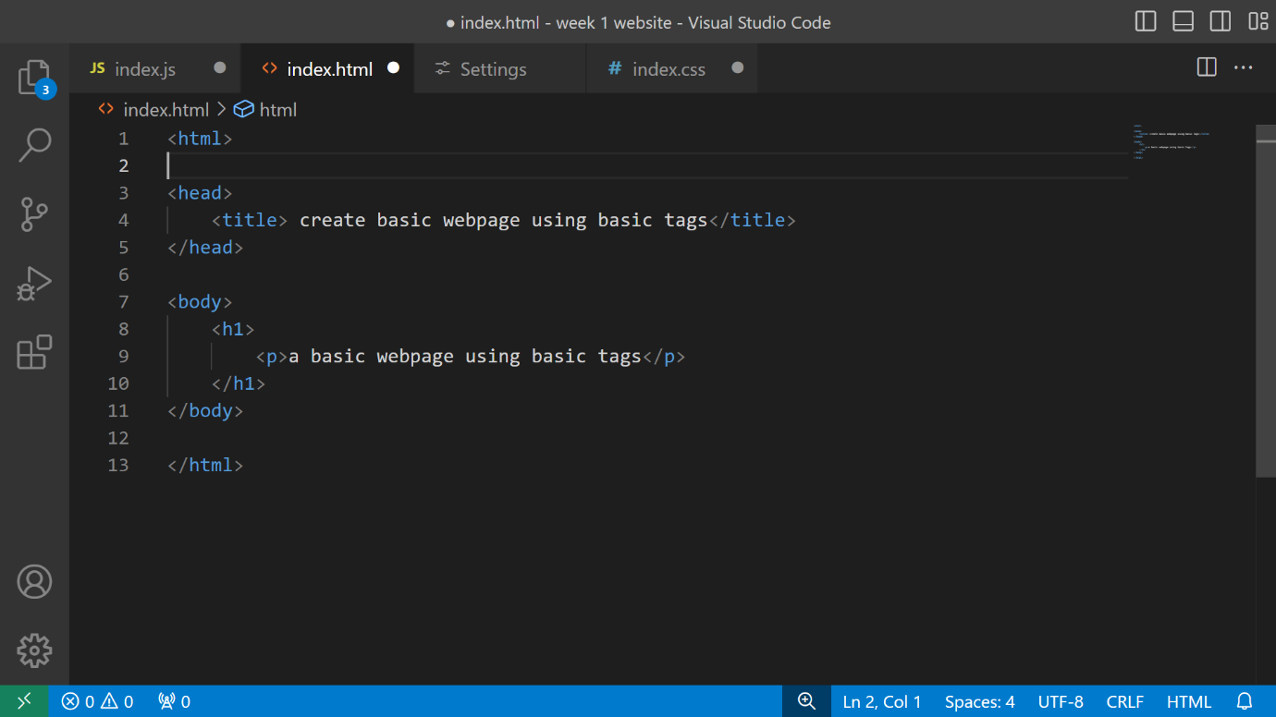

OUTPUT: -

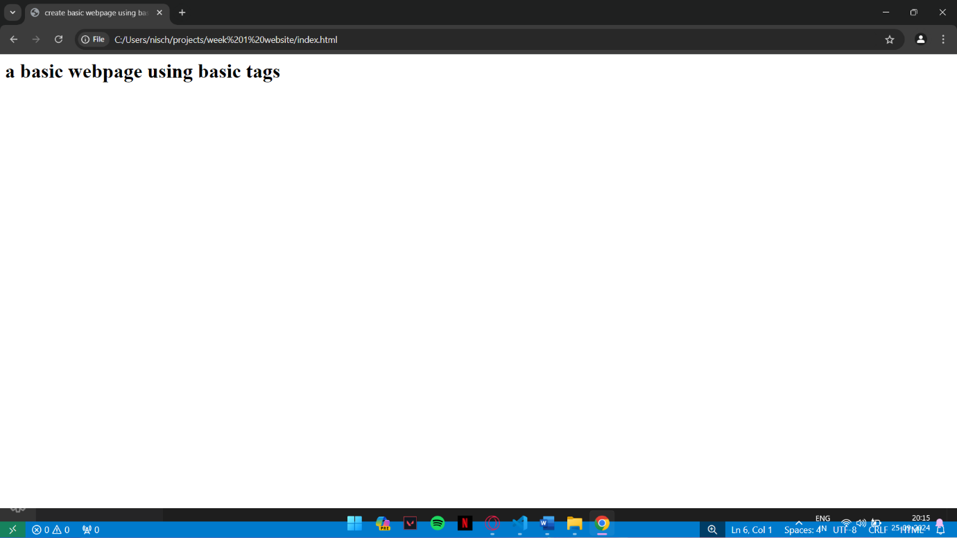

Q2: - Create a web page that displays your name to the screen.

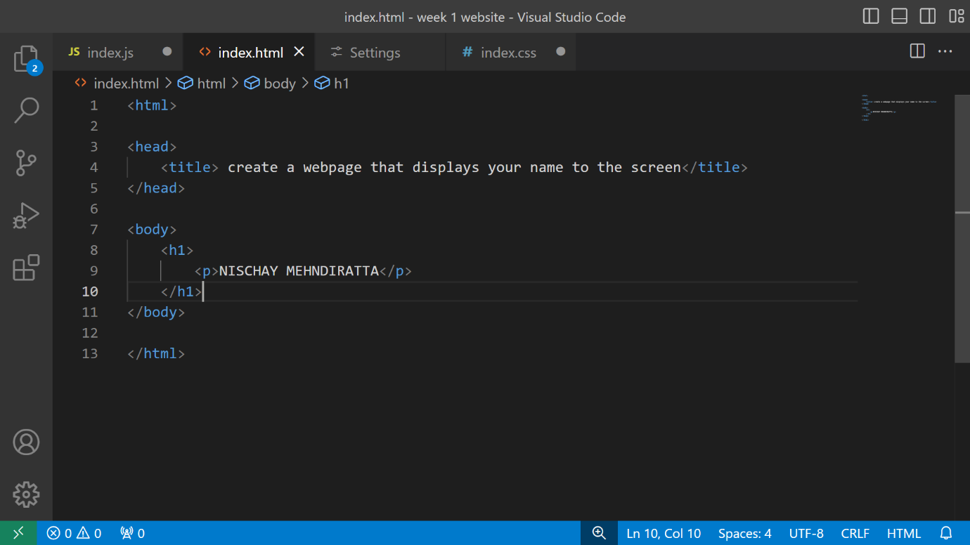

OUTPUT: -

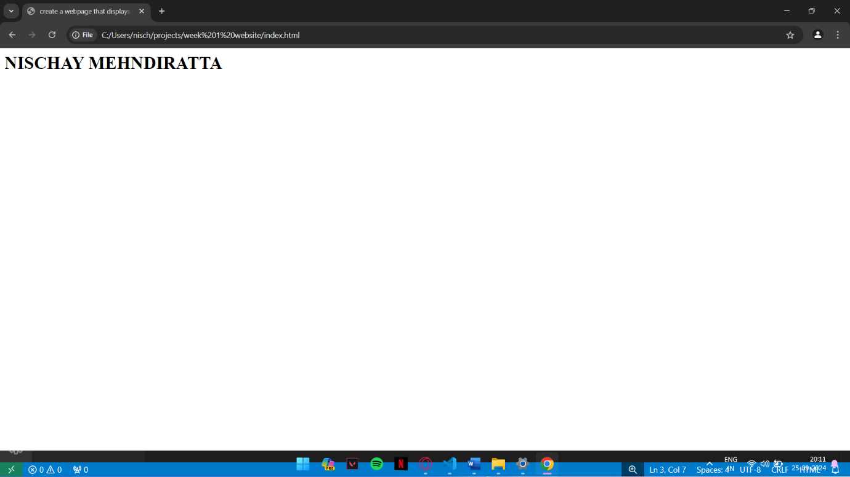

Q3: - Create a web page and show the output from 1-10 in separate lines.

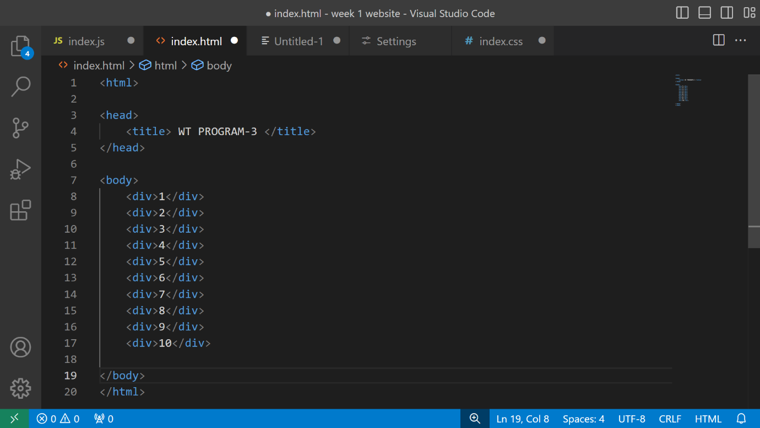

OUTPUT: -

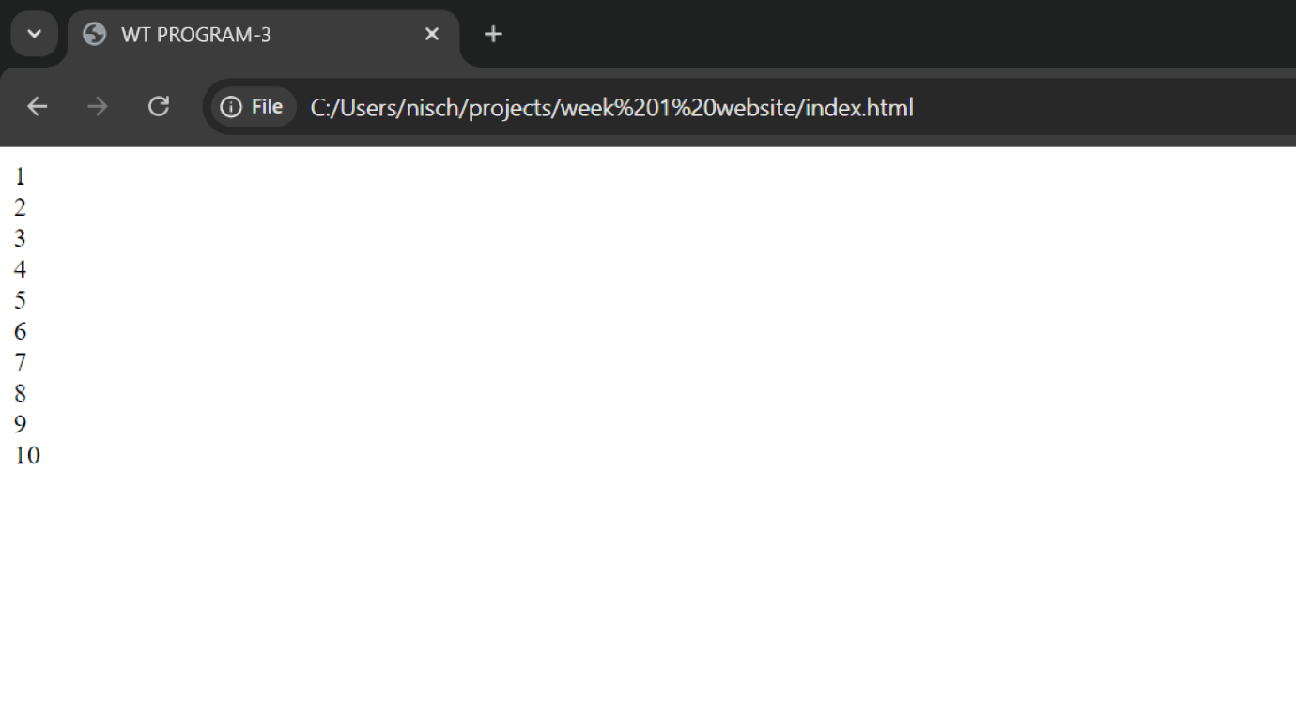

Q4: - Create a web page and show the output from 1 to 10 in separate lines, each number being in a different colour.

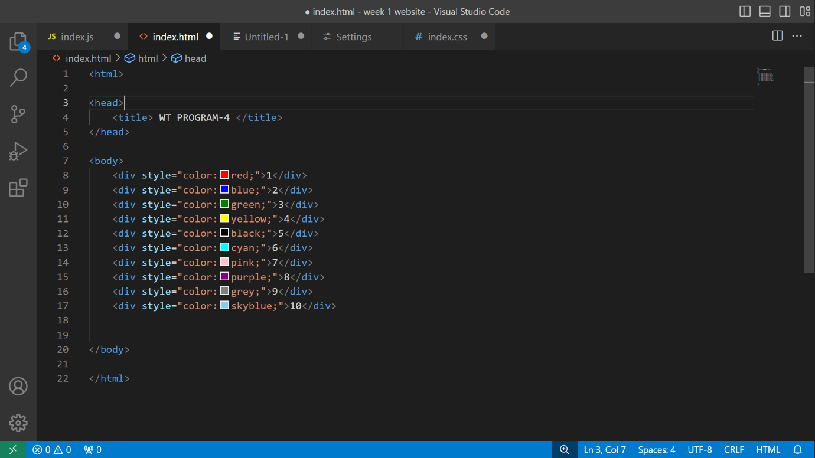

OUTPUT: -

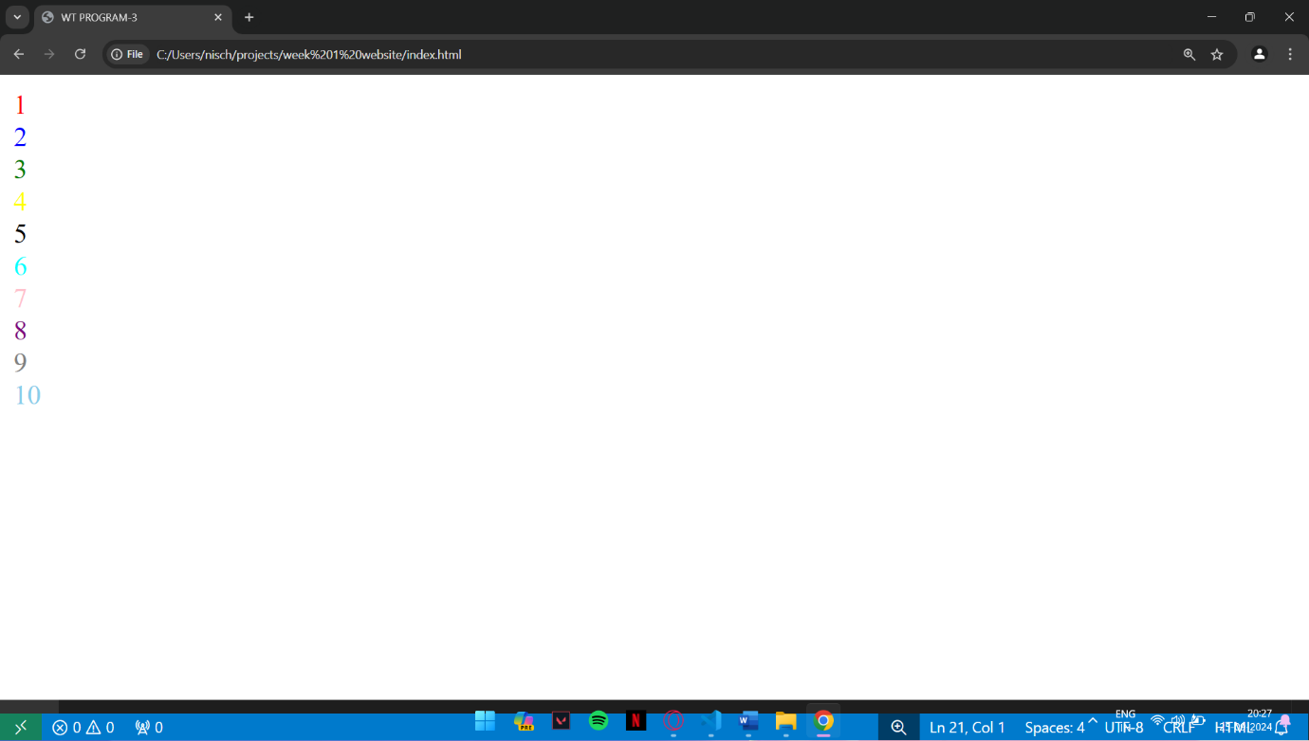

Q5: -How do I make a picture as a background on my webpage?

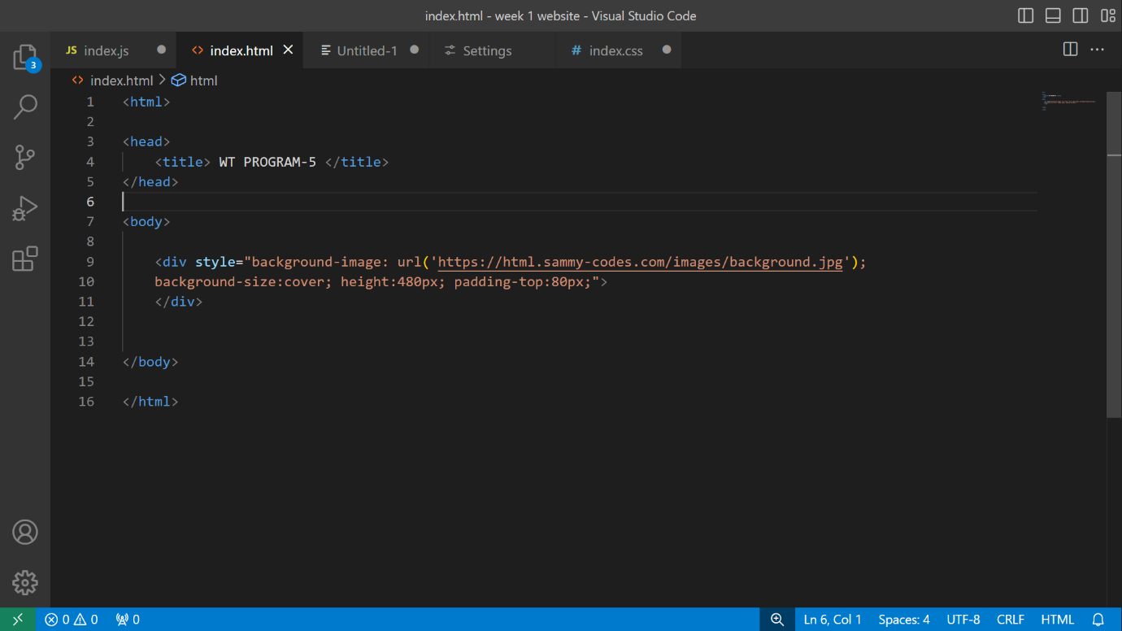

OUTPUT: -

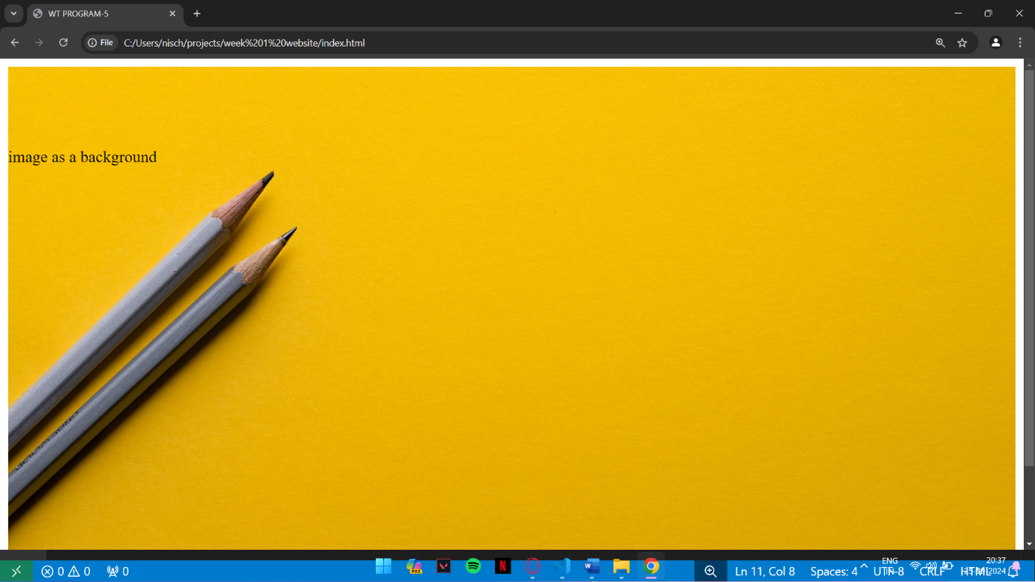

Q6: - Create a web page to print a paragraph with 4-5 sentences, each sentence shall have a different font.

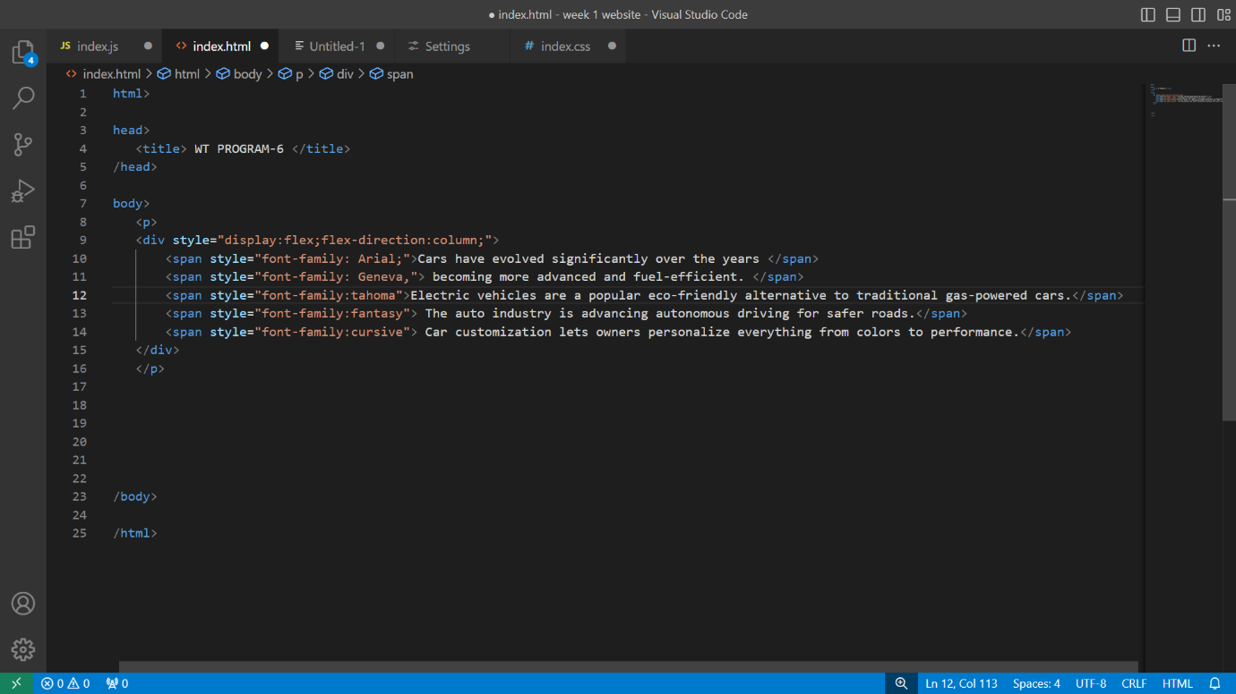

OUTPUT: -

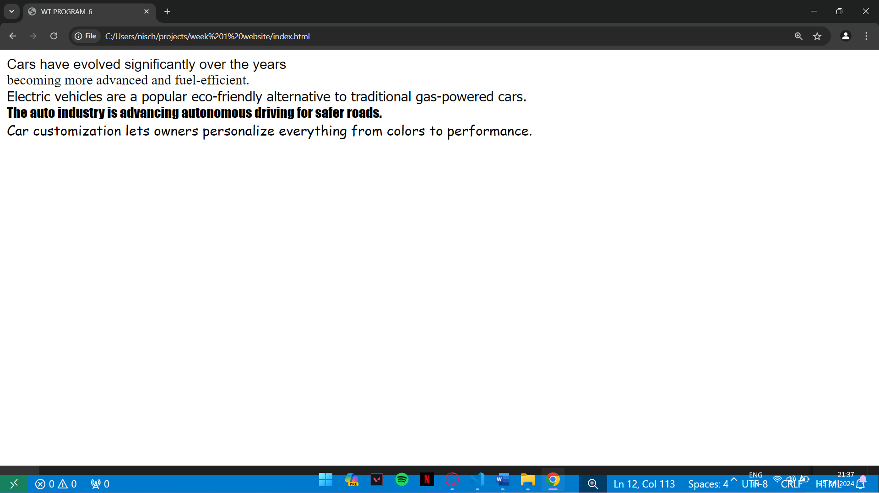

Q7: - Write a HTML code to print a paragraph that is description of the book, it shall include the title of the book. its author name; name and title should be underlined and all adjectives shall bold and Italics.

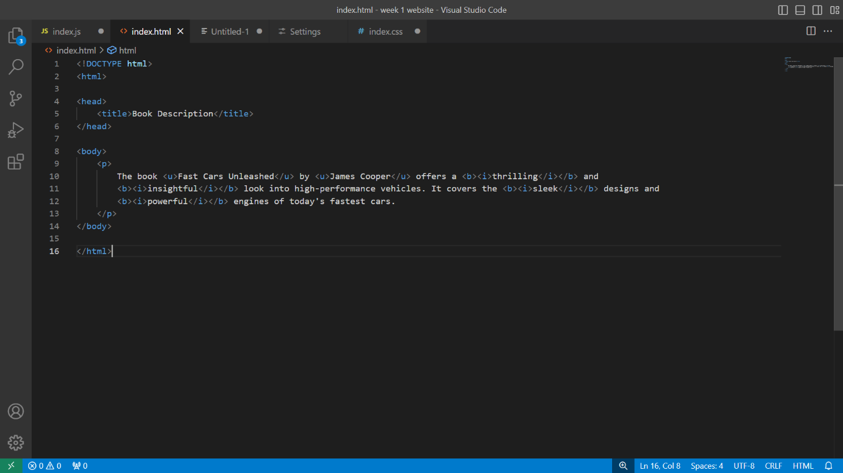

OUTPUT: -

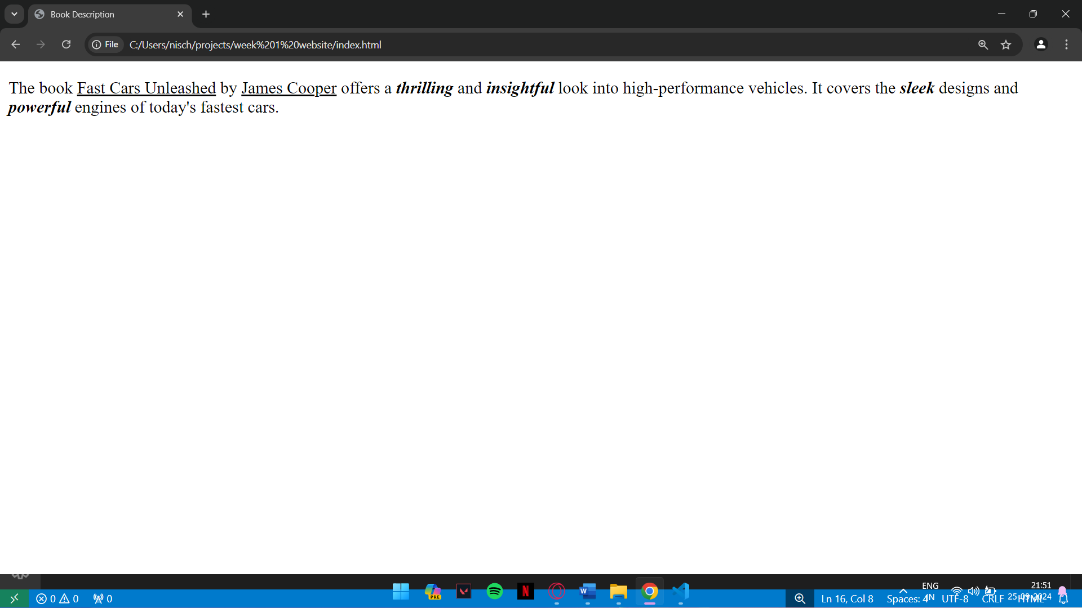

Q8: - Write HTML code to print your name using Heading tag, every letter shall be of different

heading size.

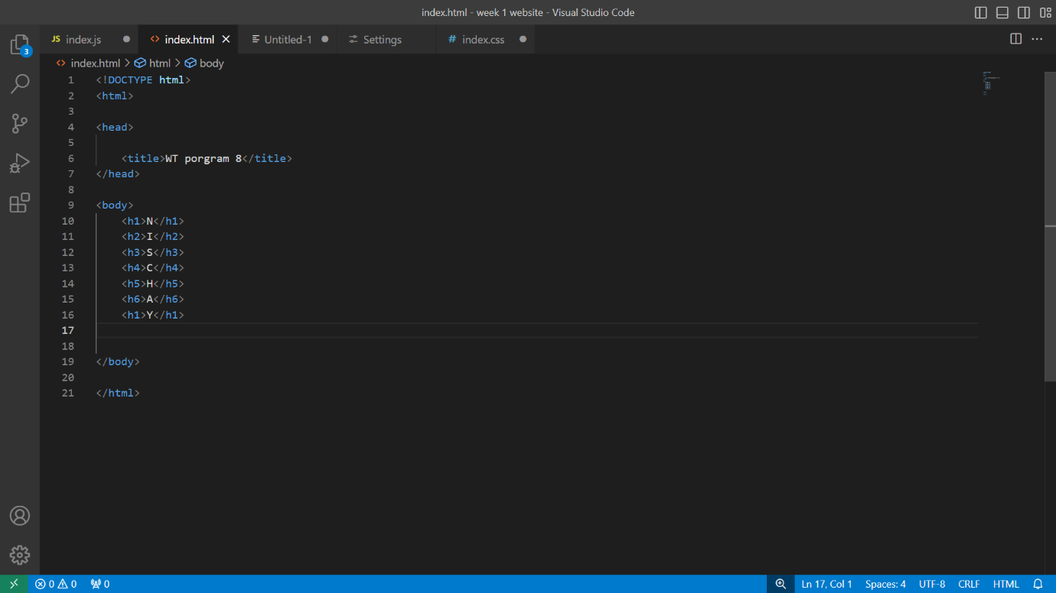

OUTPUT: -

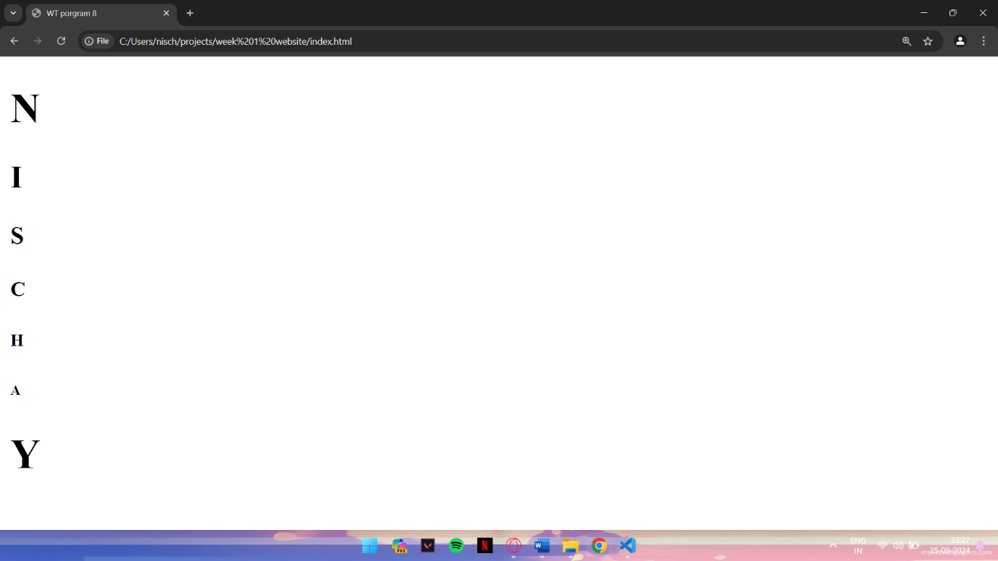

Q9: - Write HTML code to print the sequence of numbers 1-20. Each number shall be in different

line with number 2 next to it as subscript, an equal sign and the result.

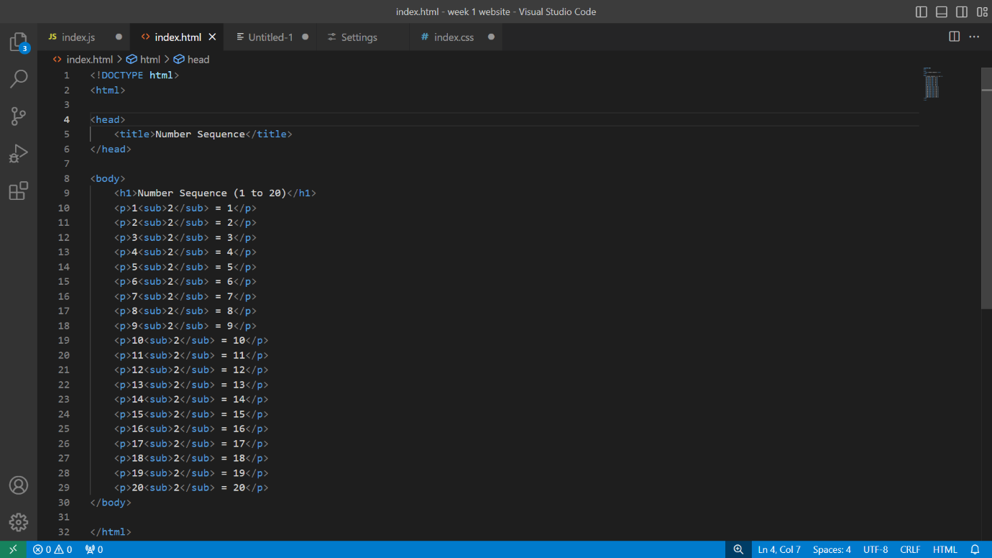

OUTPUT: -

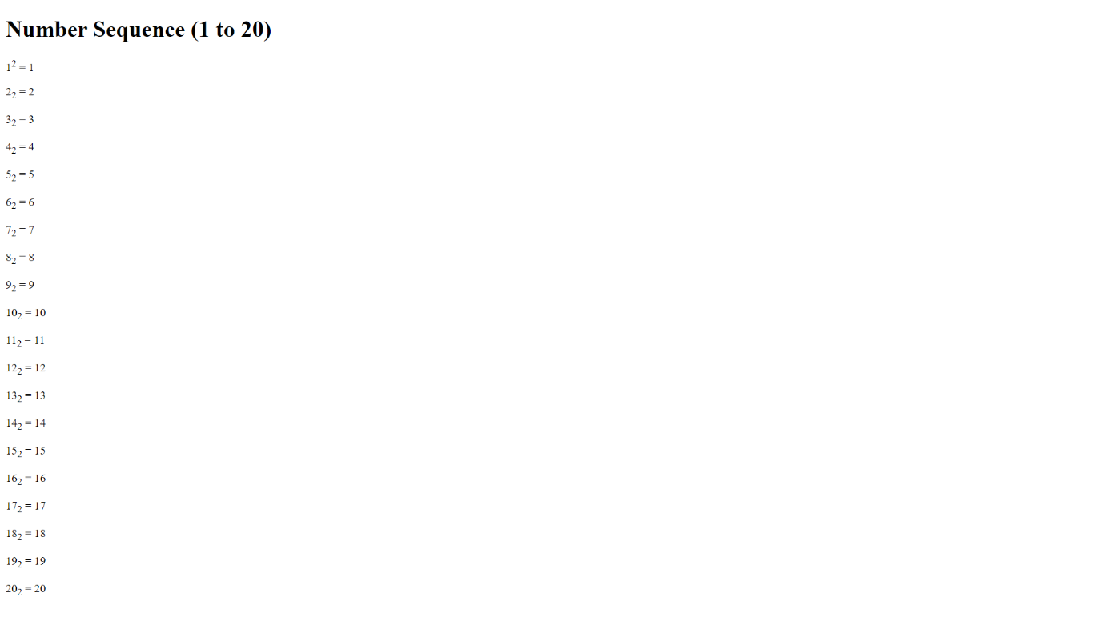

Q10: - Write HTML code to display an image with border of size with width 200, height 200 pixels, leaving Horizontal space and Vertical space of your choice with image hanging in the right side on the screen.

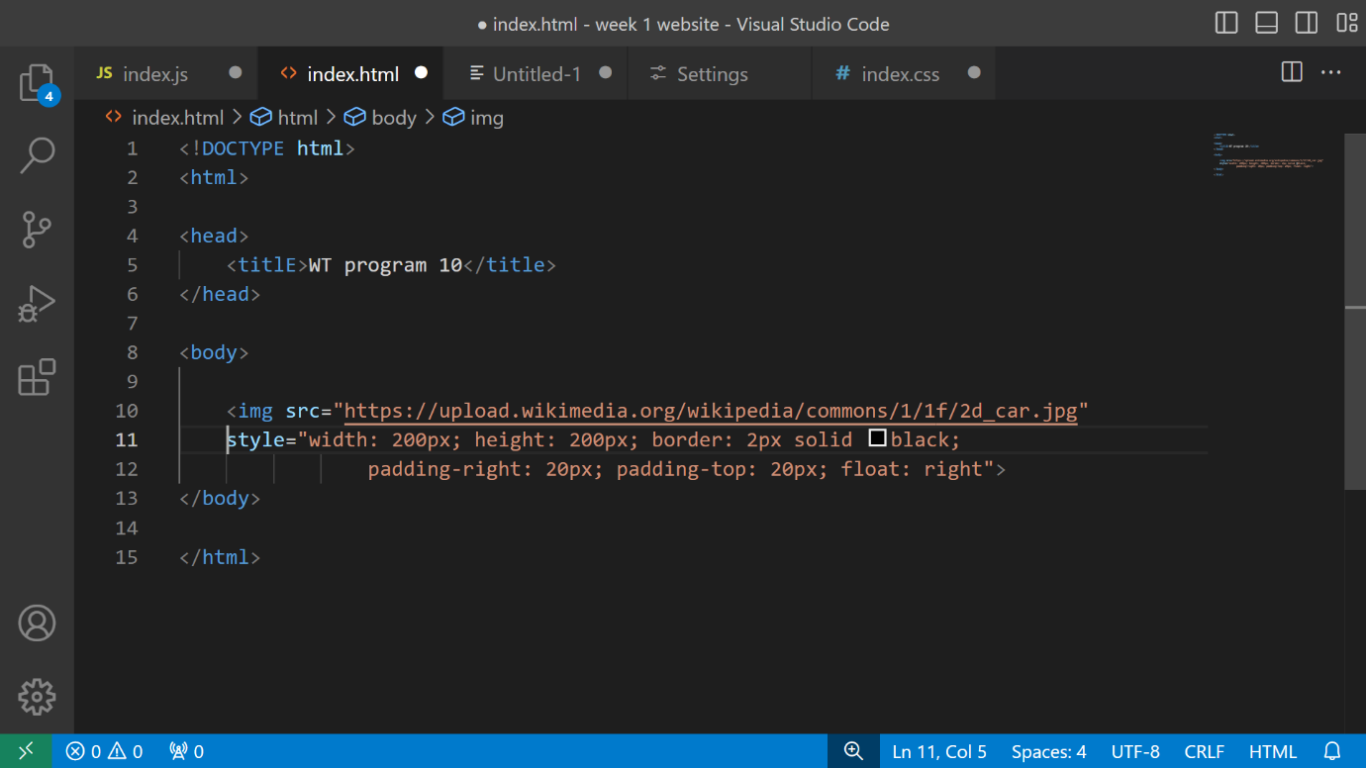

OUTPUT: -

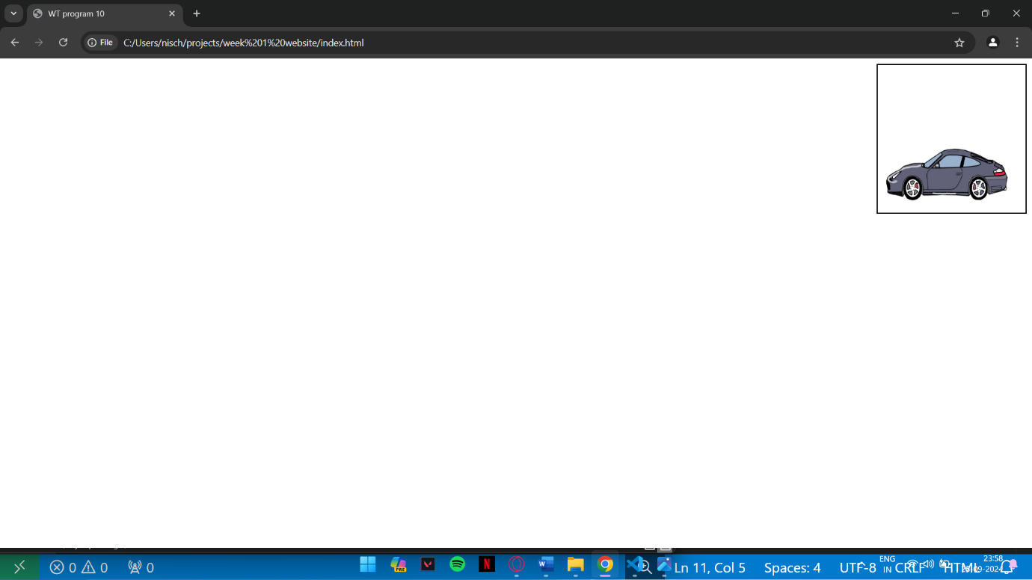

Q11: - Write HTML code to create a web page with heading. The heading shall be displayed at the top-centre of the page and the image shall be at the centre, just below the heading.

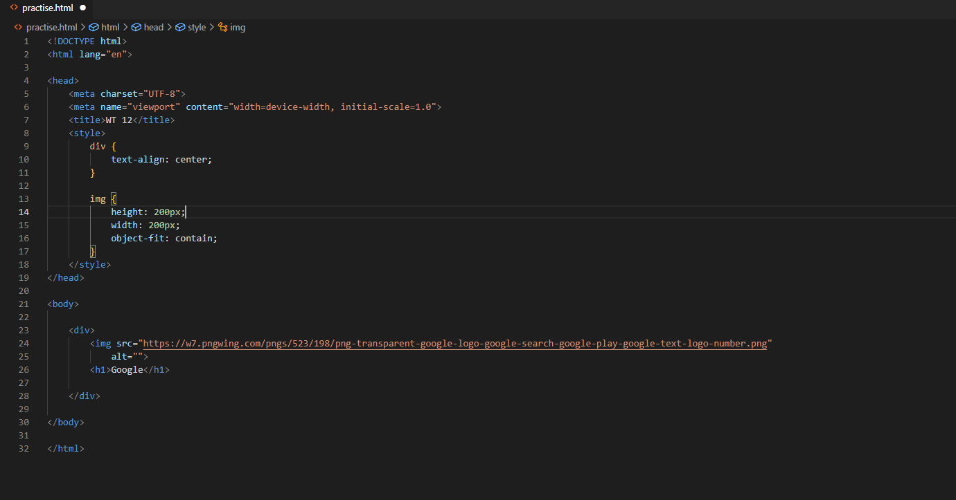

OUTPUT: -

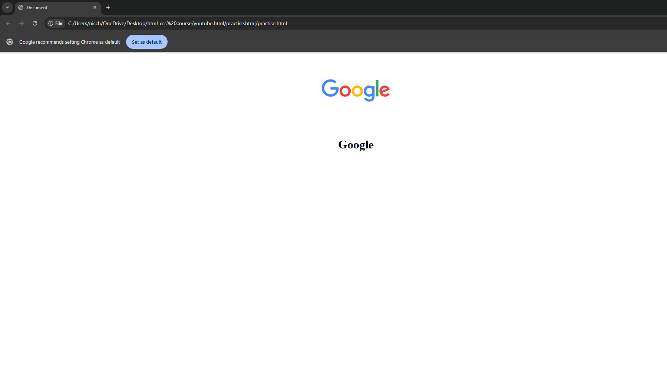

Q12: - Write HTML code using Multimedia tags.

OUTPUT: -

Q13: - Create a Table using Row span and Col span taking example of student Record.

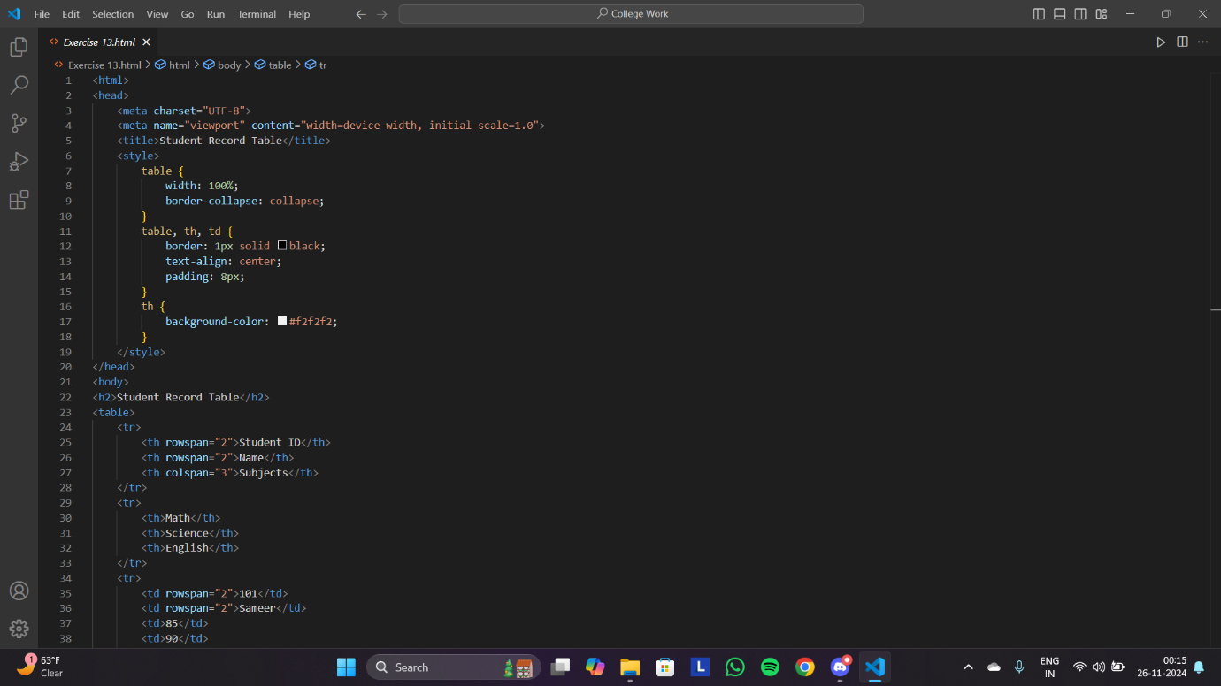

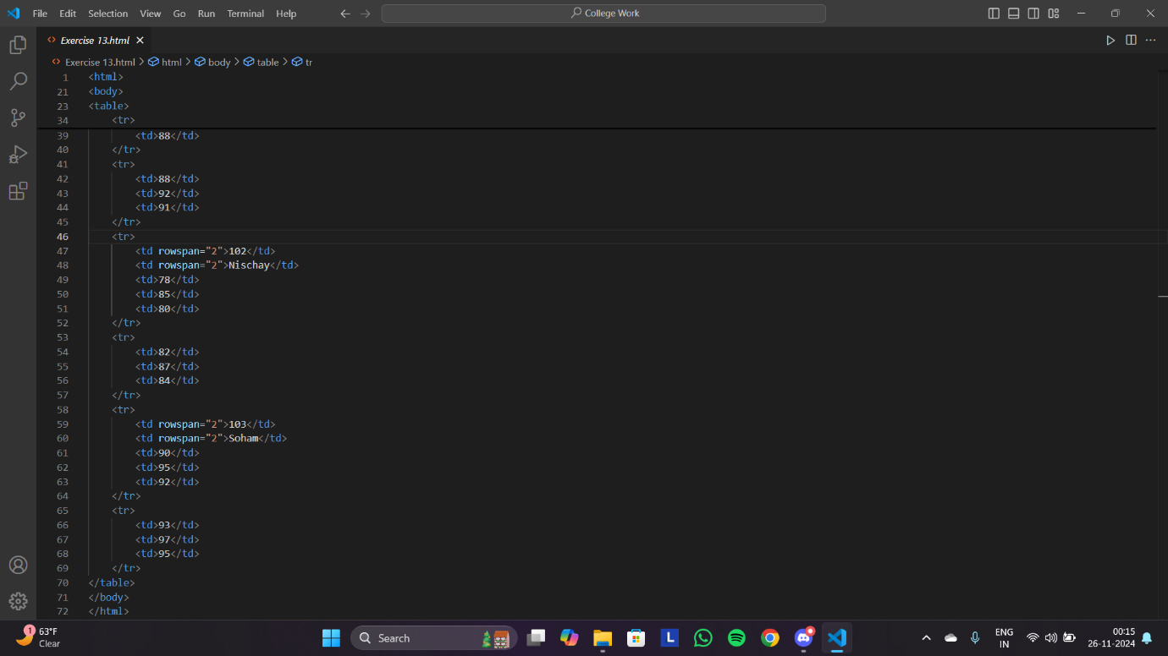

OUTPUT: -

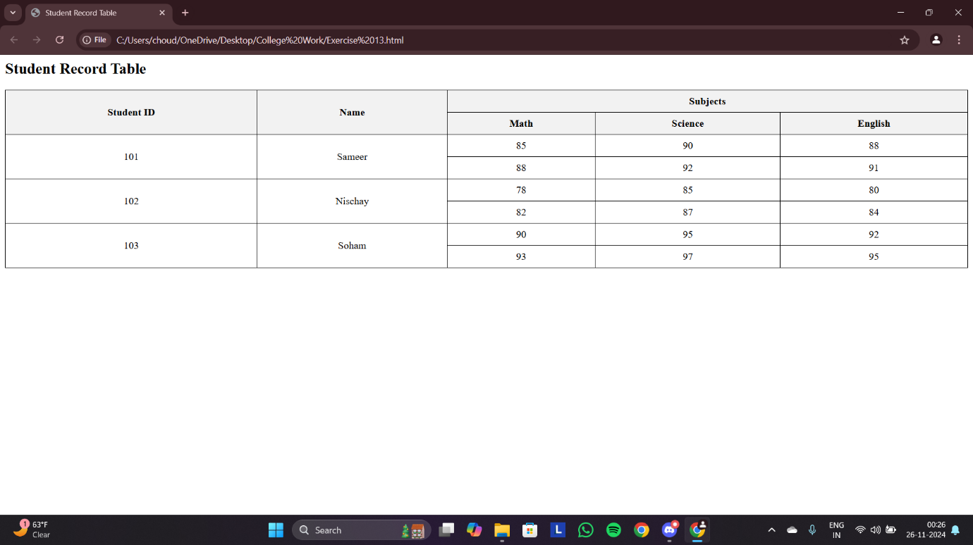

Q14: - Write HTML code using table tag <table> and cellpadding and cell spacing as its attributes.

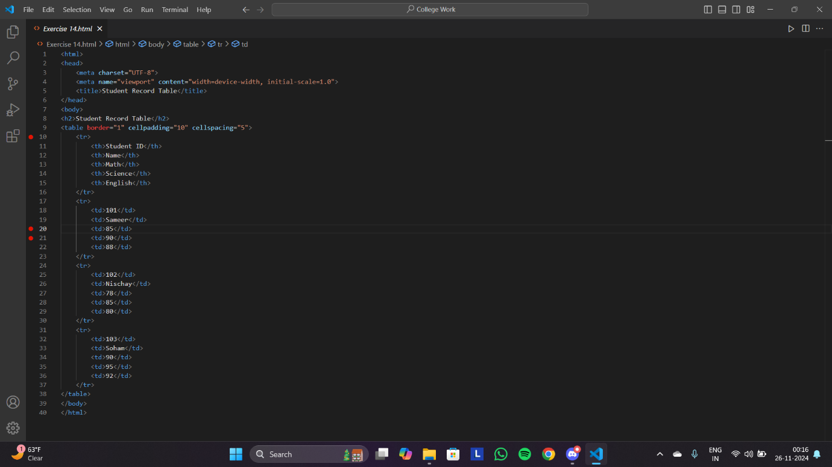

OUTPUT: -

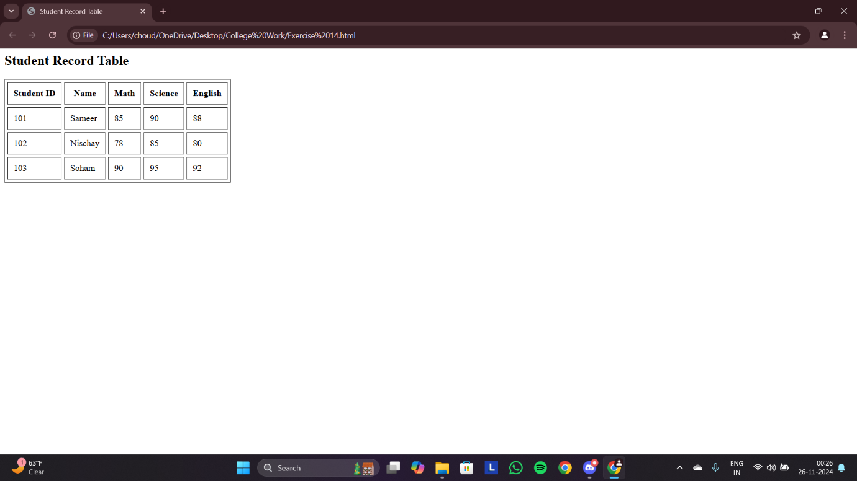

Q15: - Create unordered, ordered and definition Lists taking example of your subjects in MCA IST, 2nd and 3rd Semester.

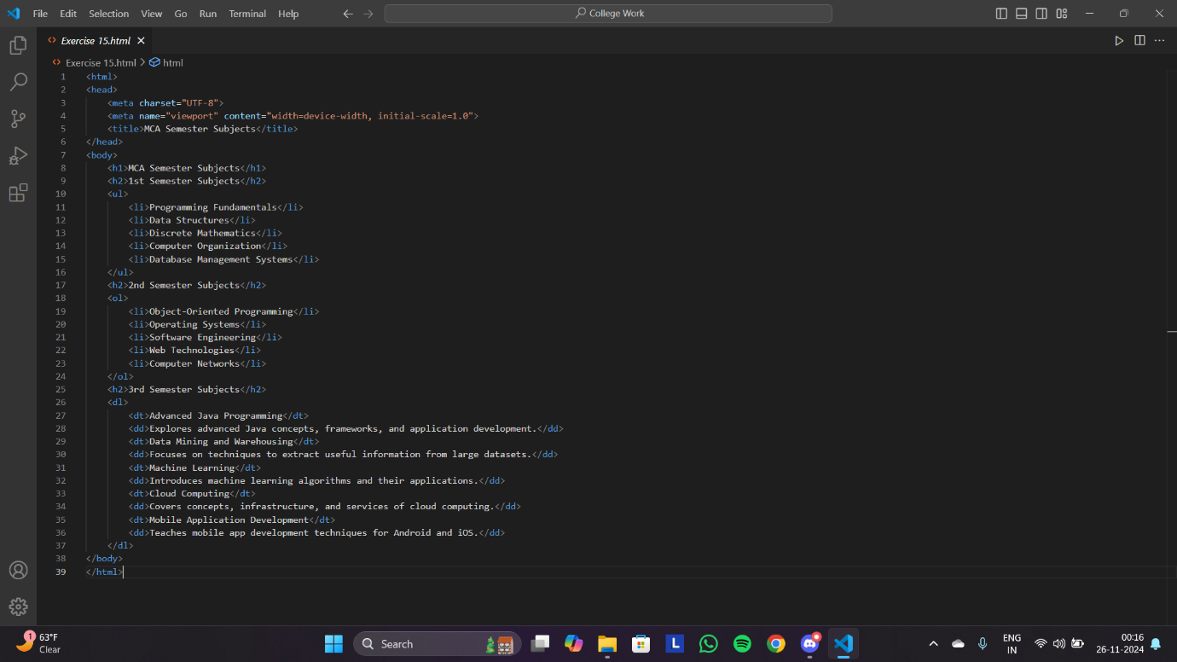

OUTPUT: -

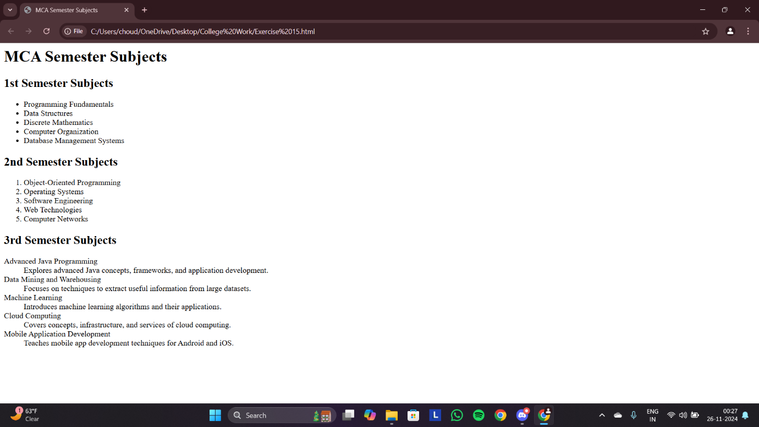

Q16: - Write HTML code using <frameset> and <frame> tag with all its attributes.

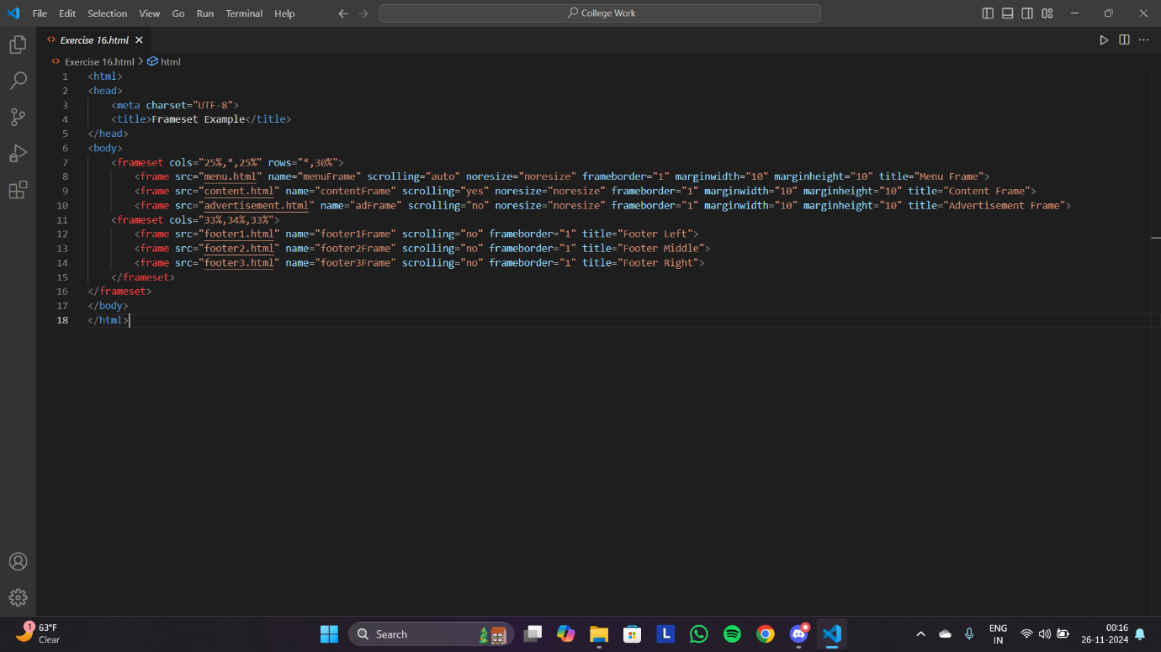

DEPREICATED TAGS HENCE NO OUTPUT.

Q17: - Write HTML code to design a form in HTML using controls and buttons such as Textbox, Text area, password, submit button, browse button, drop-down menu.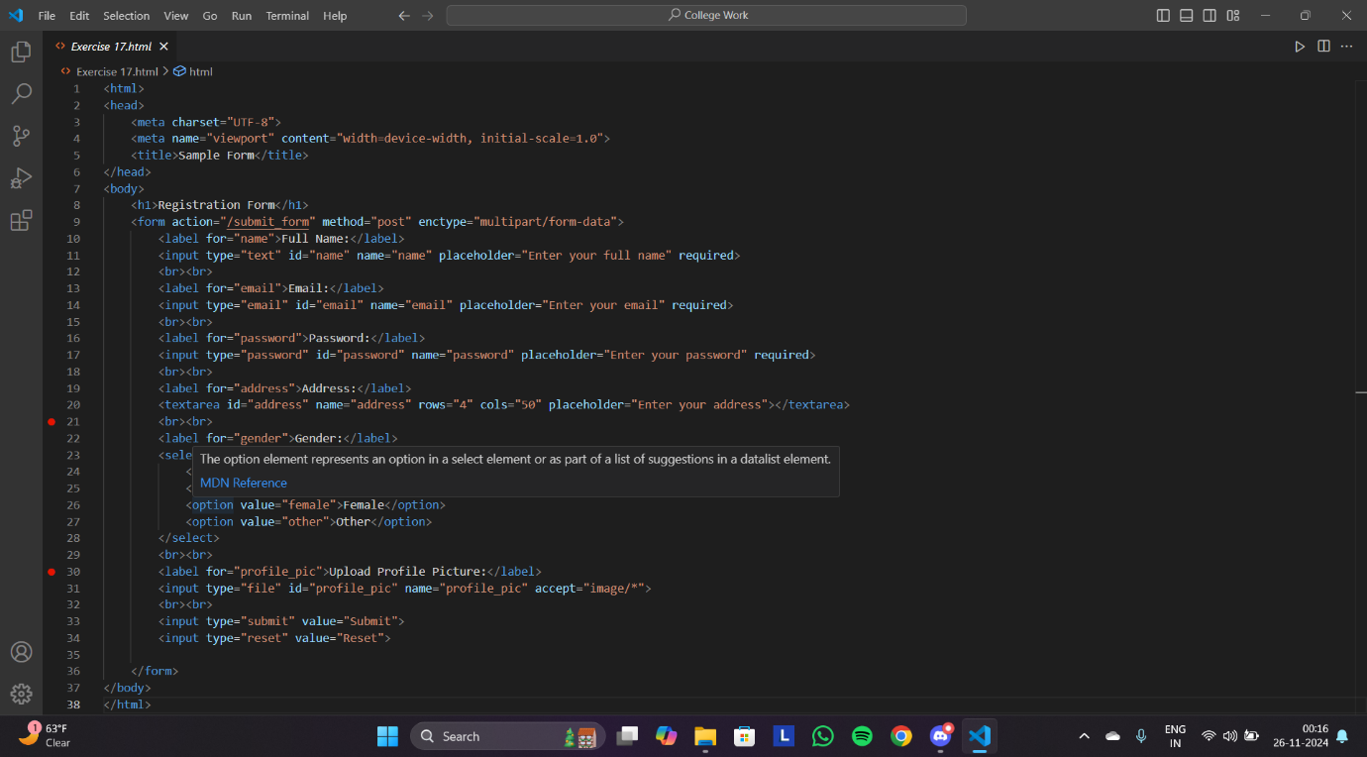

OUTPUT: -

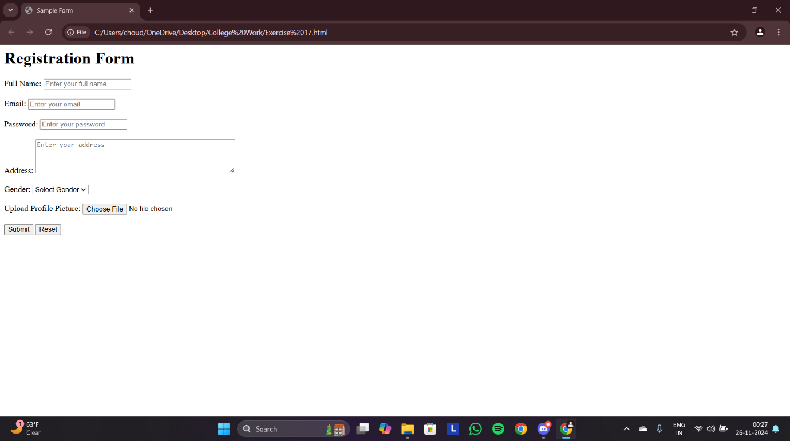

Q18: - Write HTML code to design a Registration Form in HTML.

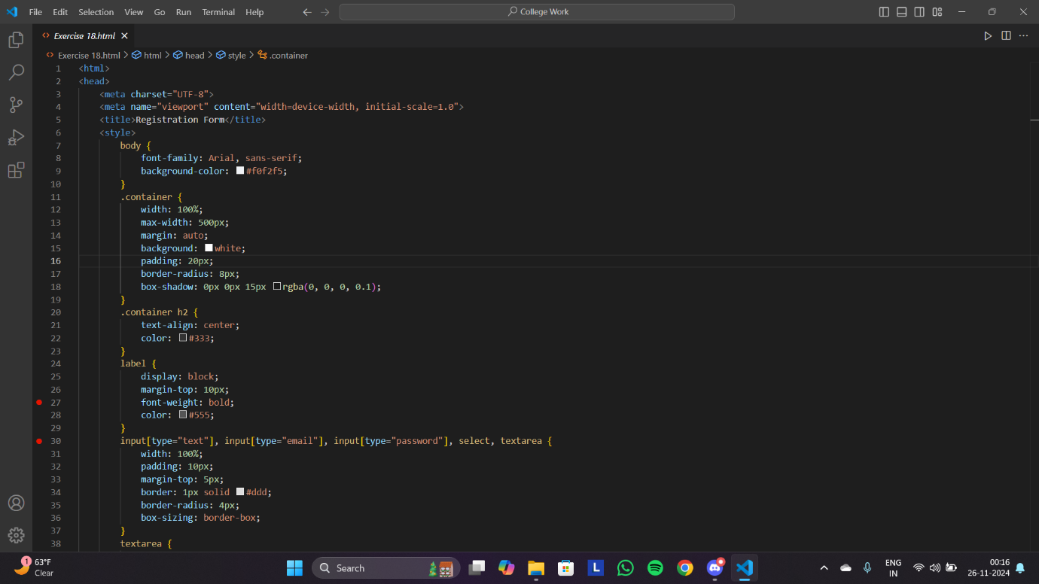

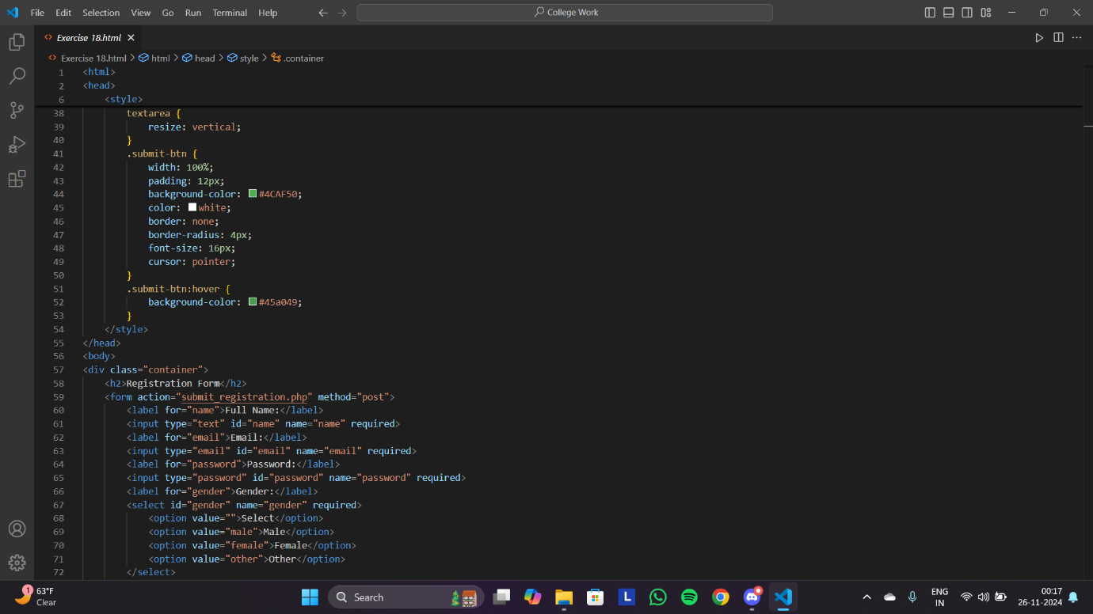

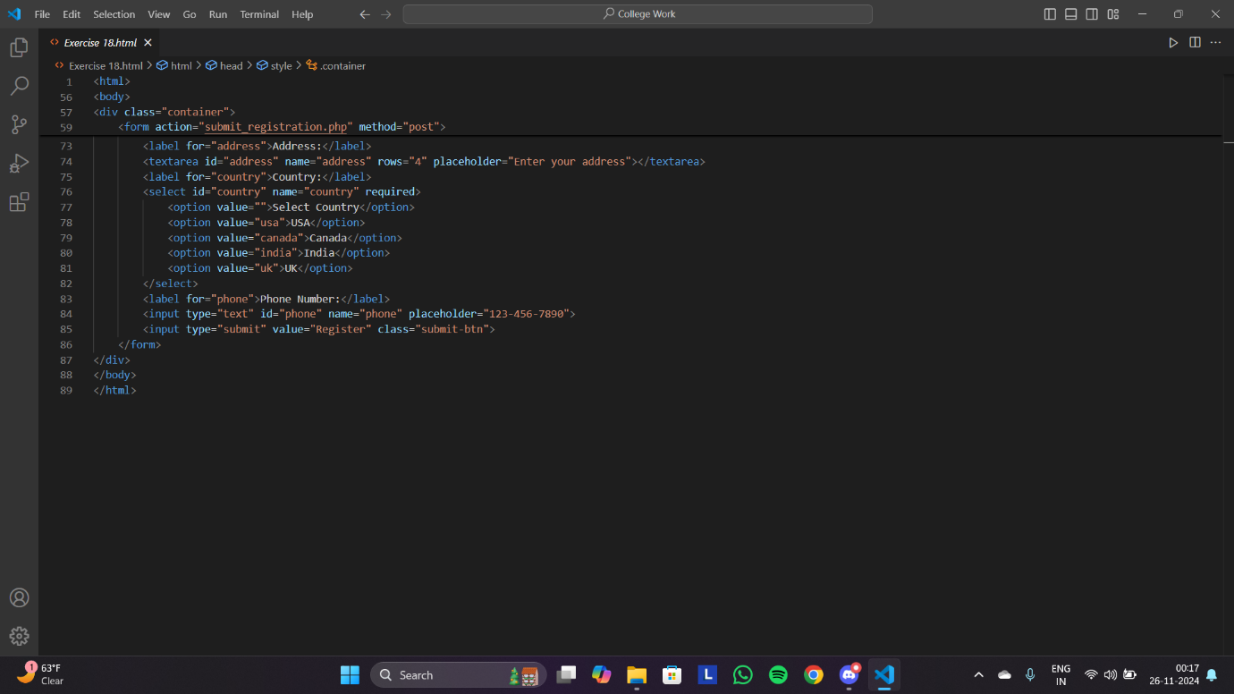

OUTPUT: -

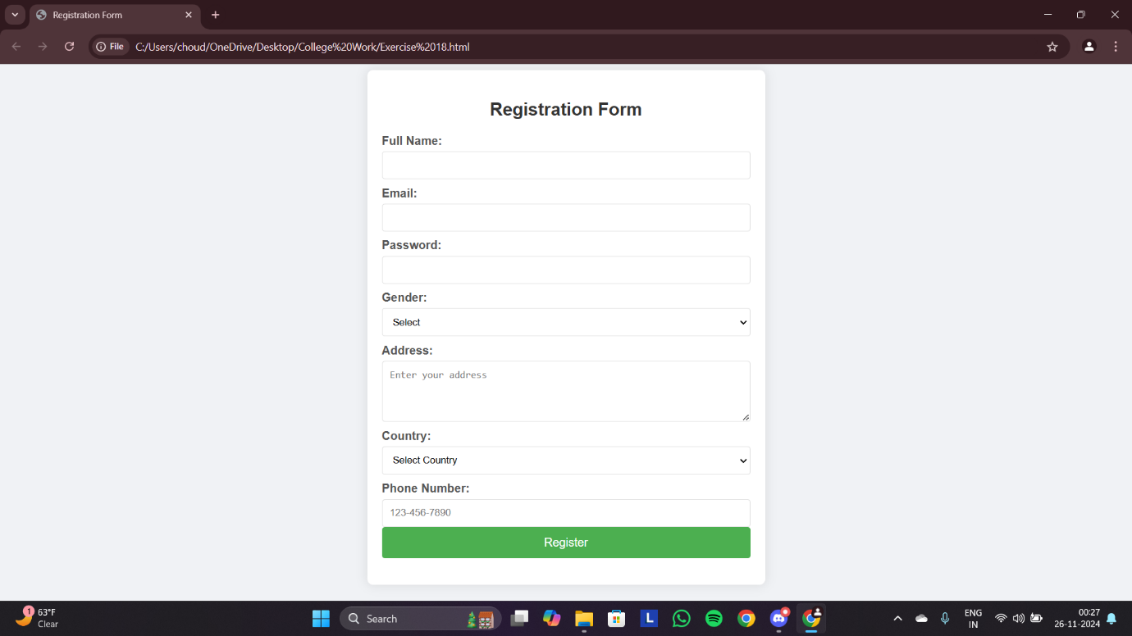

Q19: - Write HTML code to design a student admission Form in HTML.

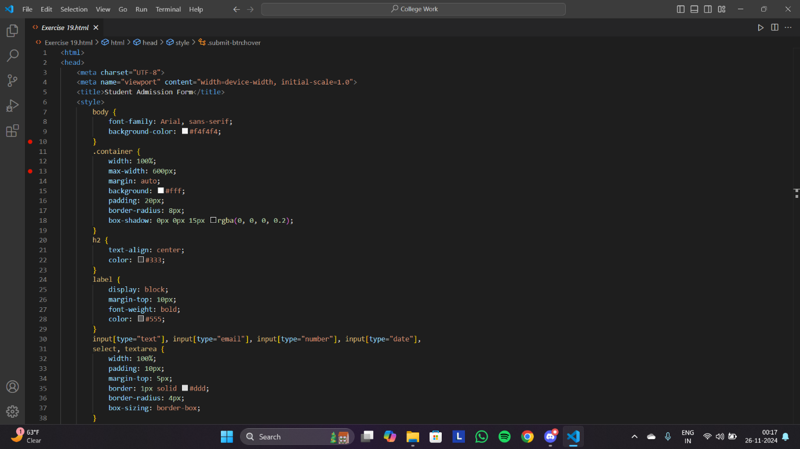

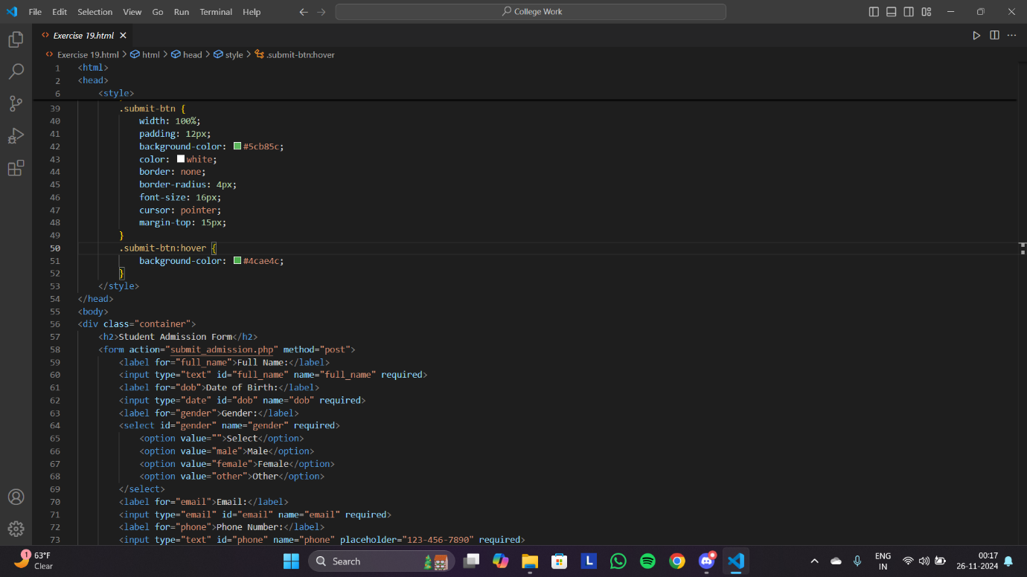

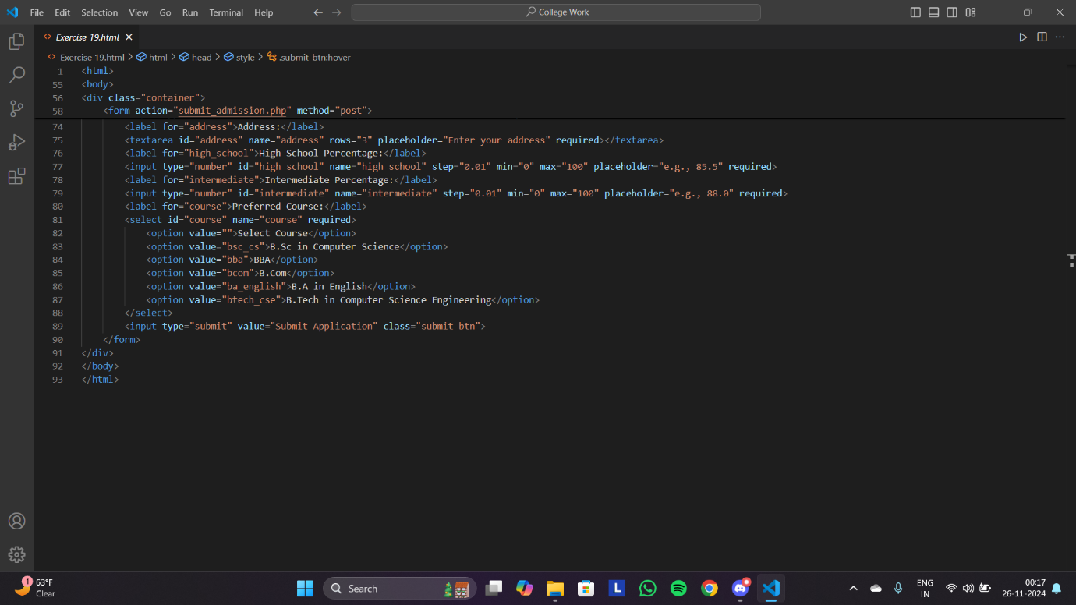

OUTPUT: -

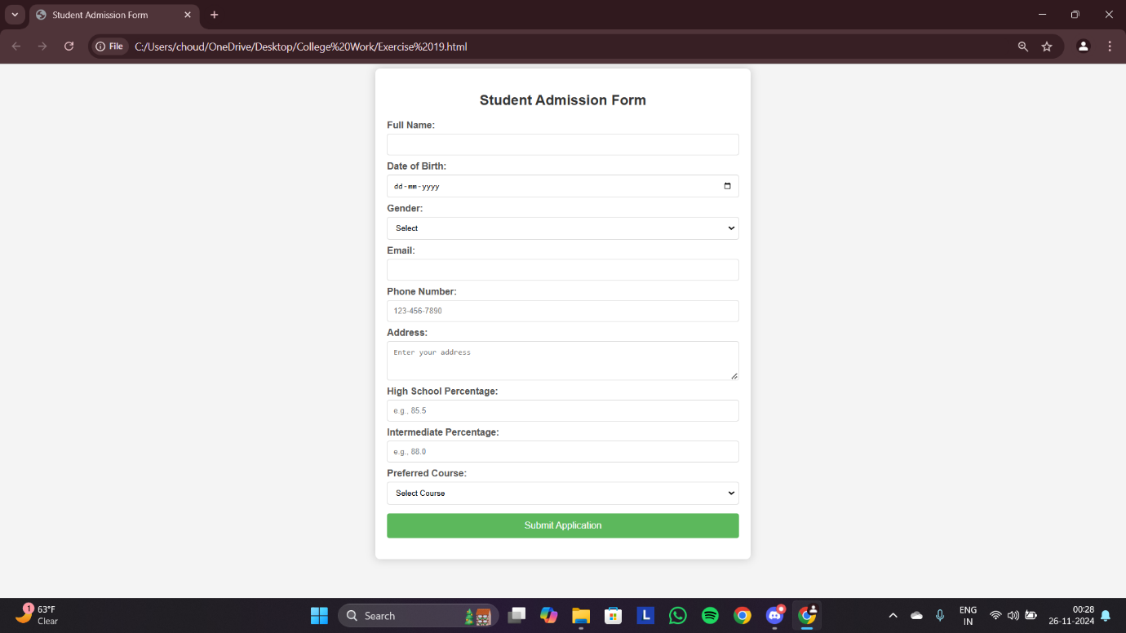

Q20: - Create a proper home page of your own using any components and styles.

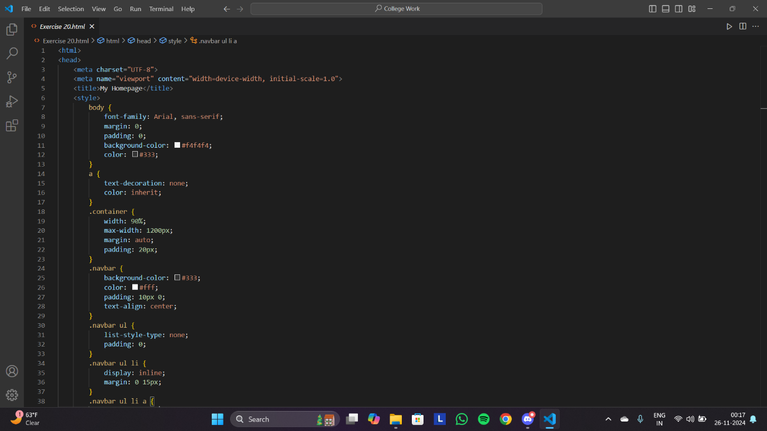

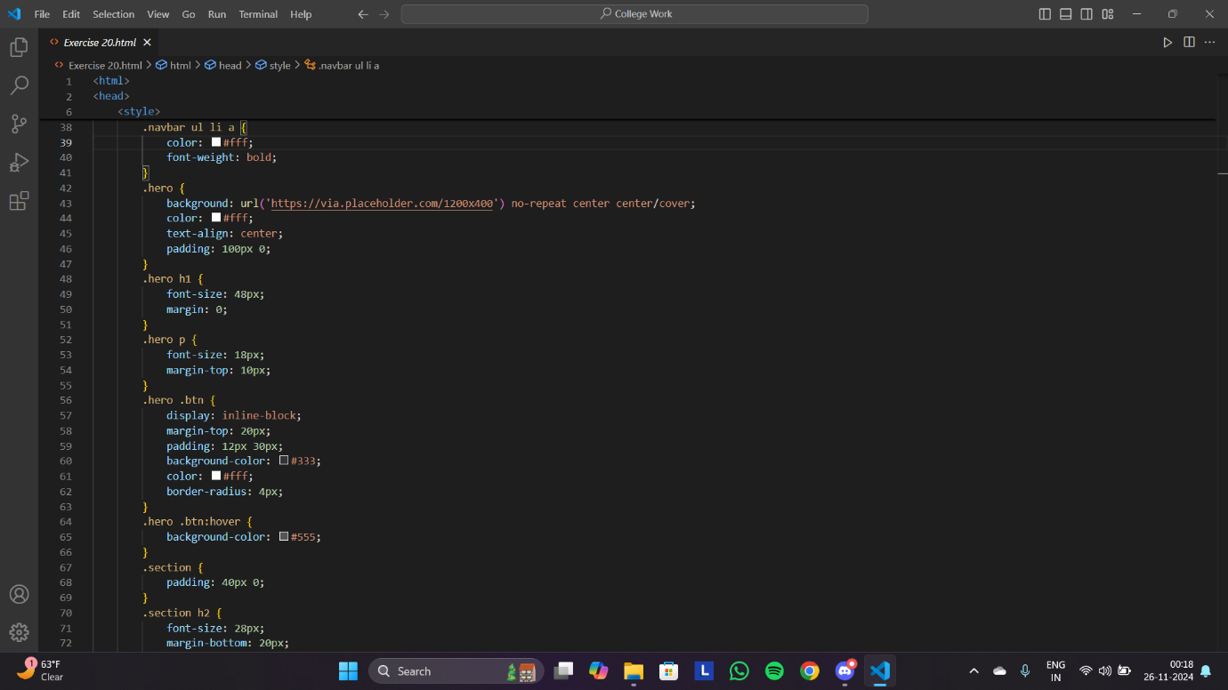

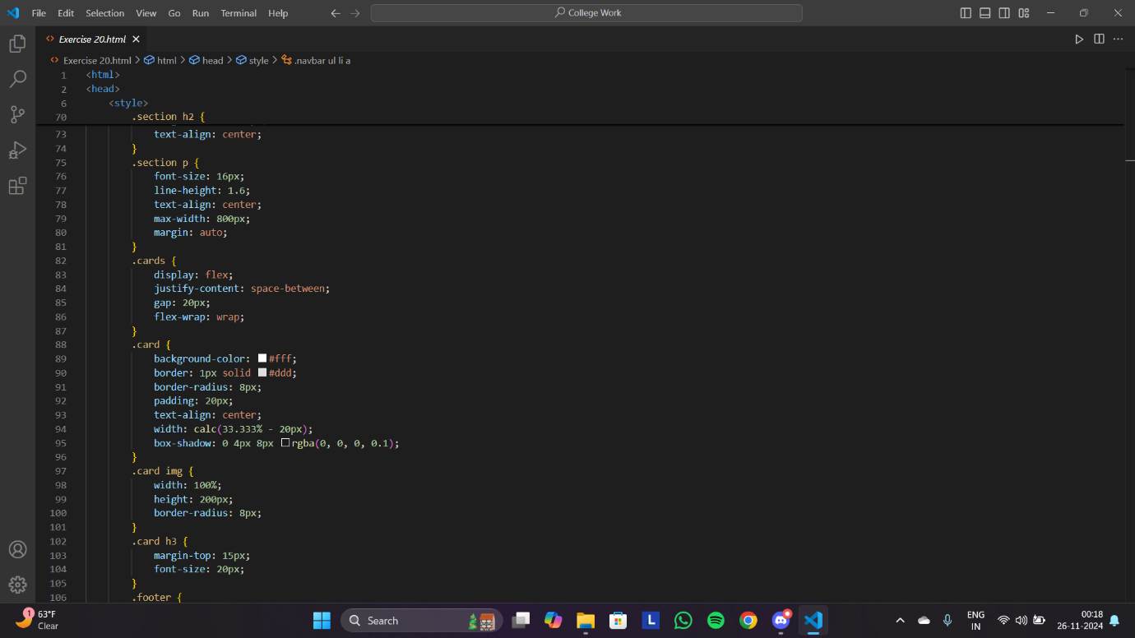

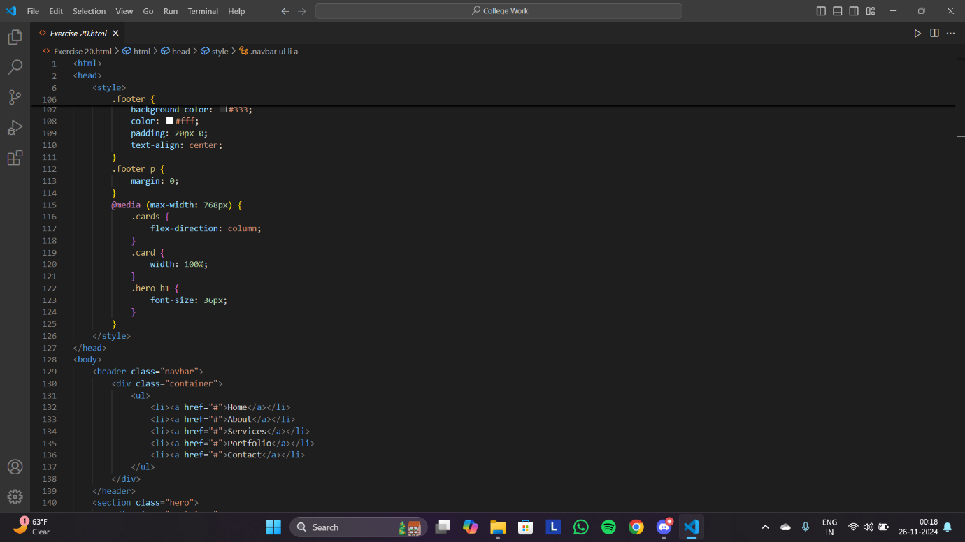

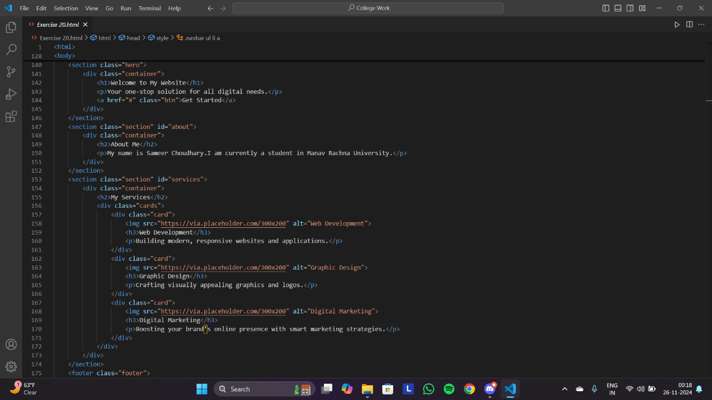

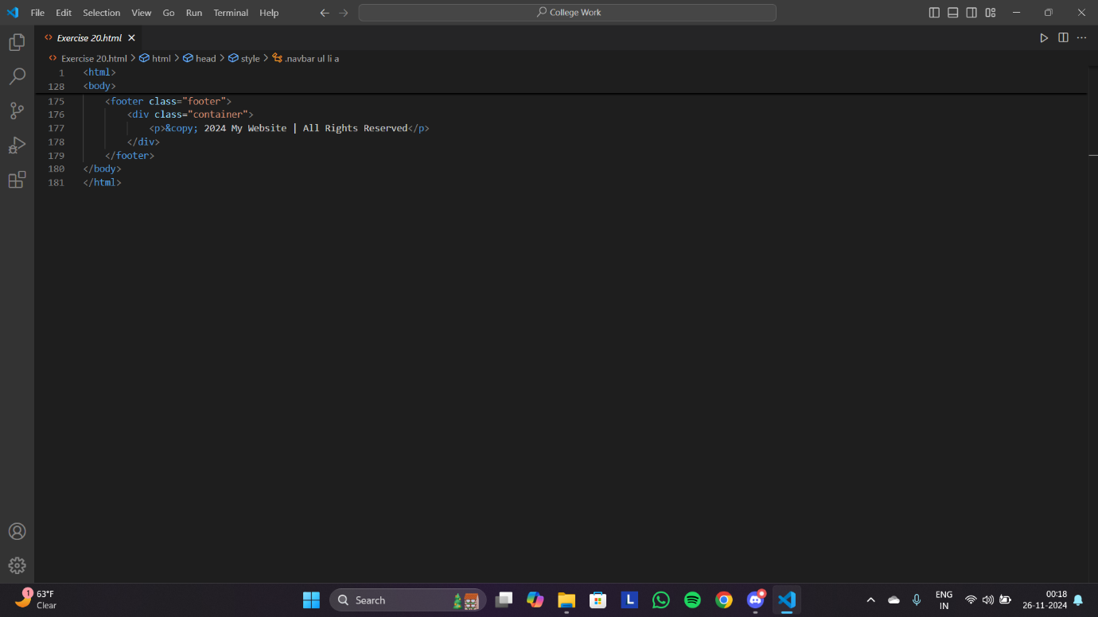

OUTPUT: -

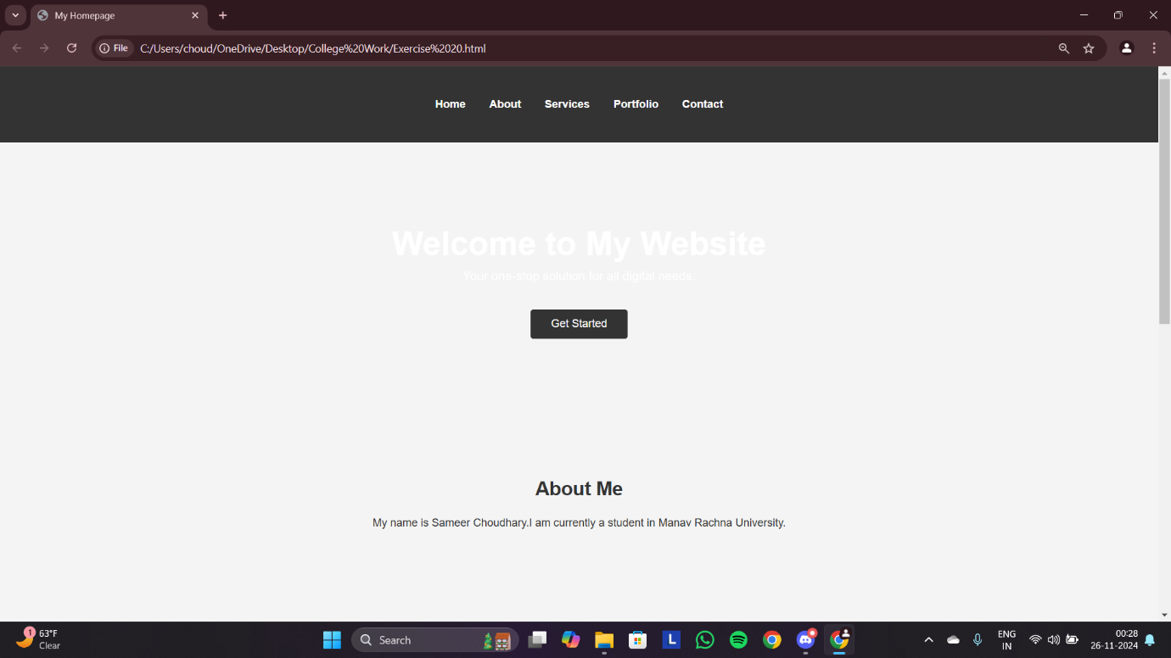

Q21: - Write HTML code for including Local hyperlinking in a web page.

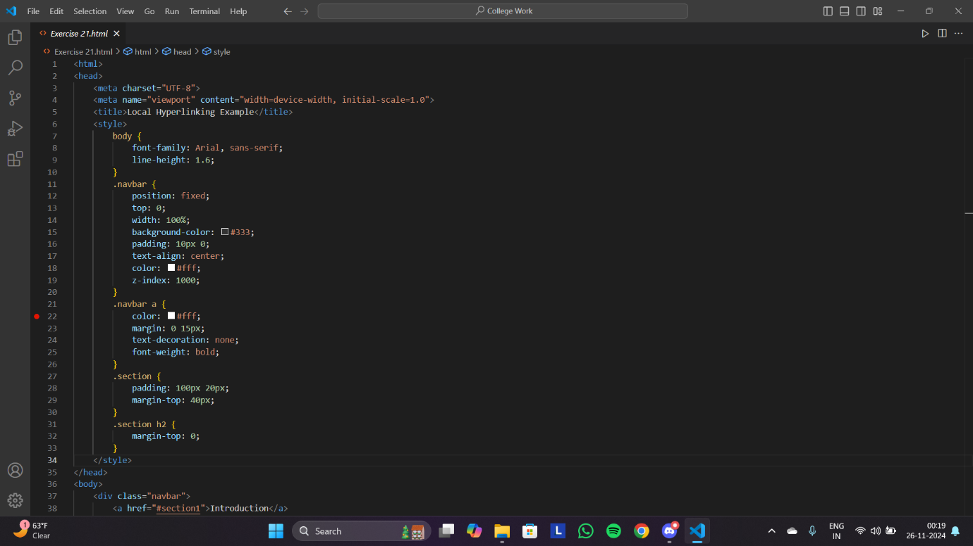

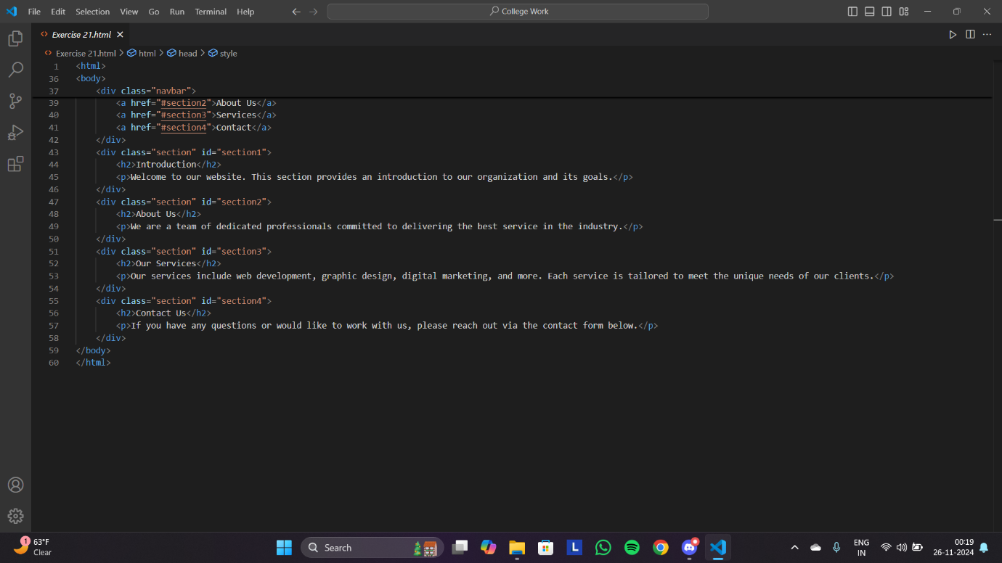

OUTPUT: -

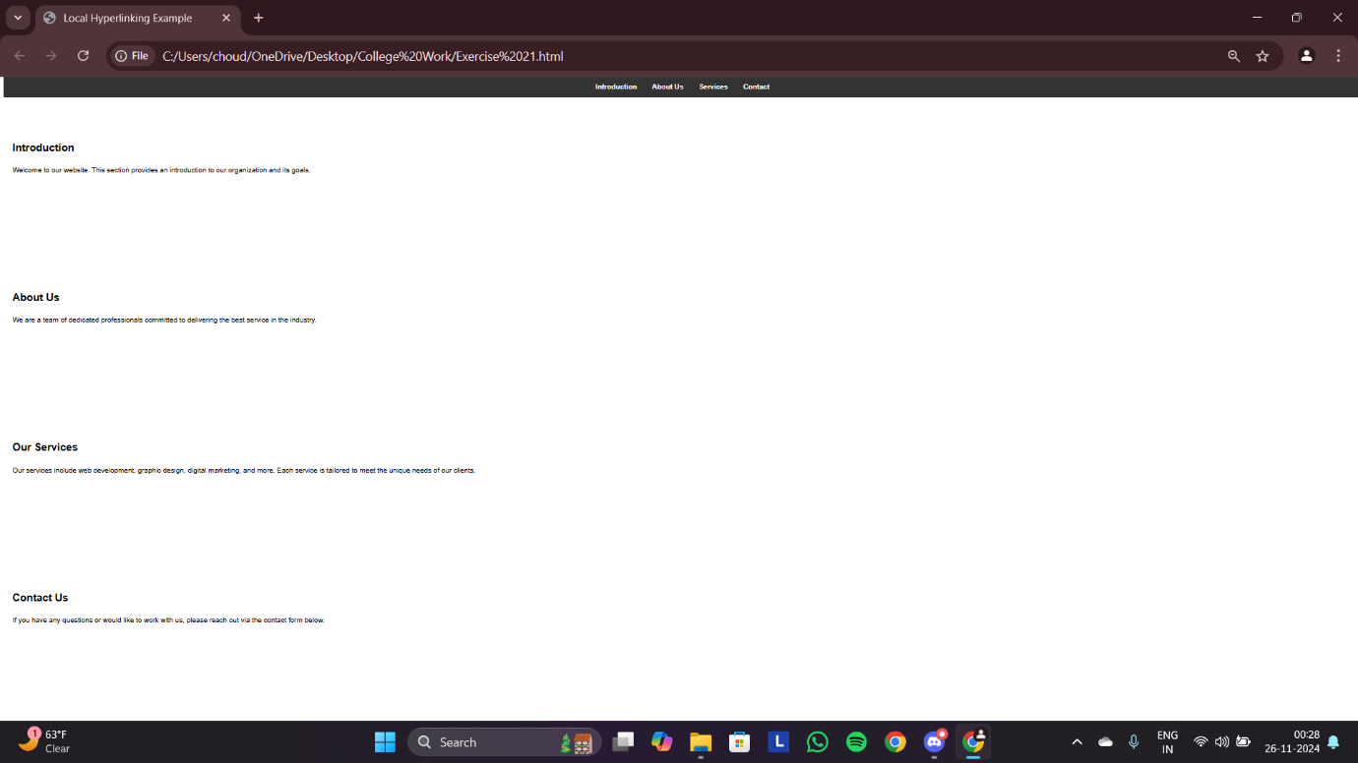

Q22: - Write HTML code for including Inter hyperlinking in a web page.

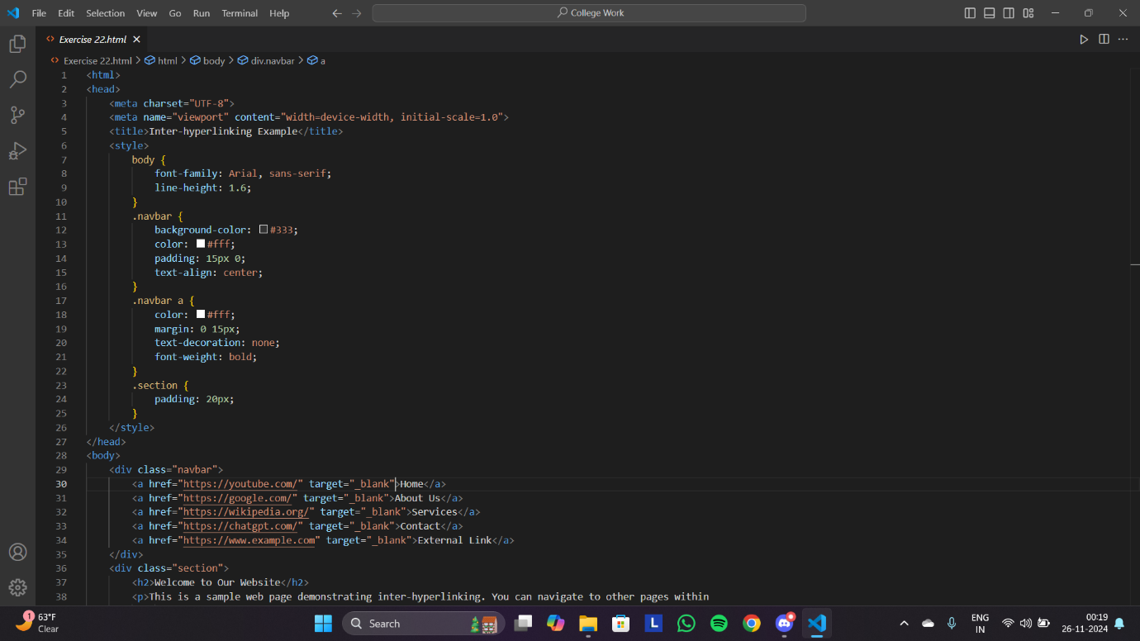

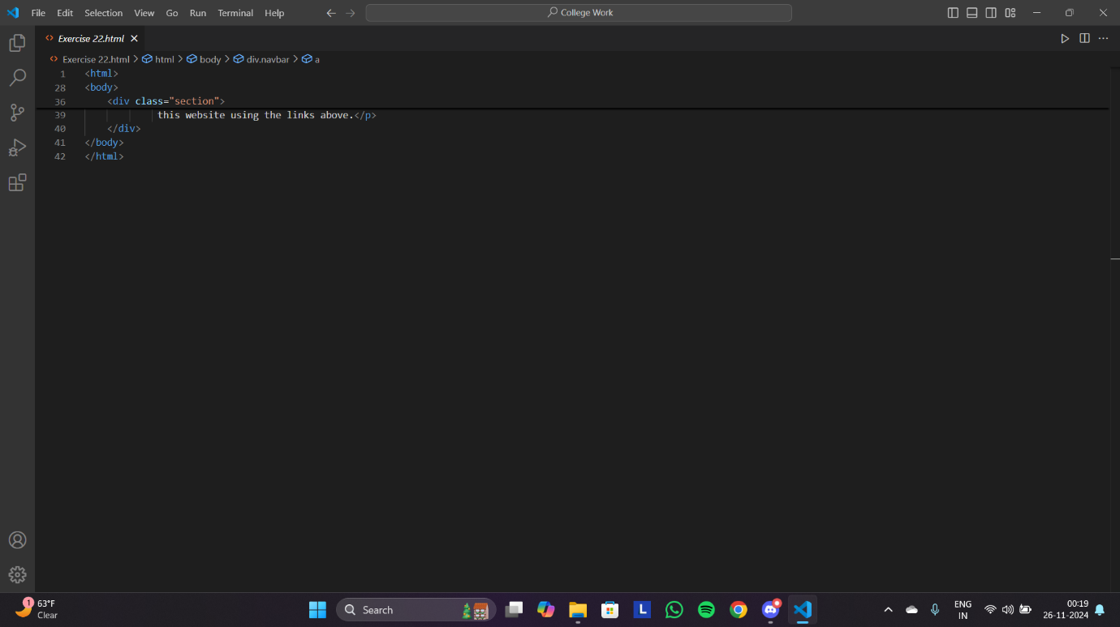

OUTPUT: - 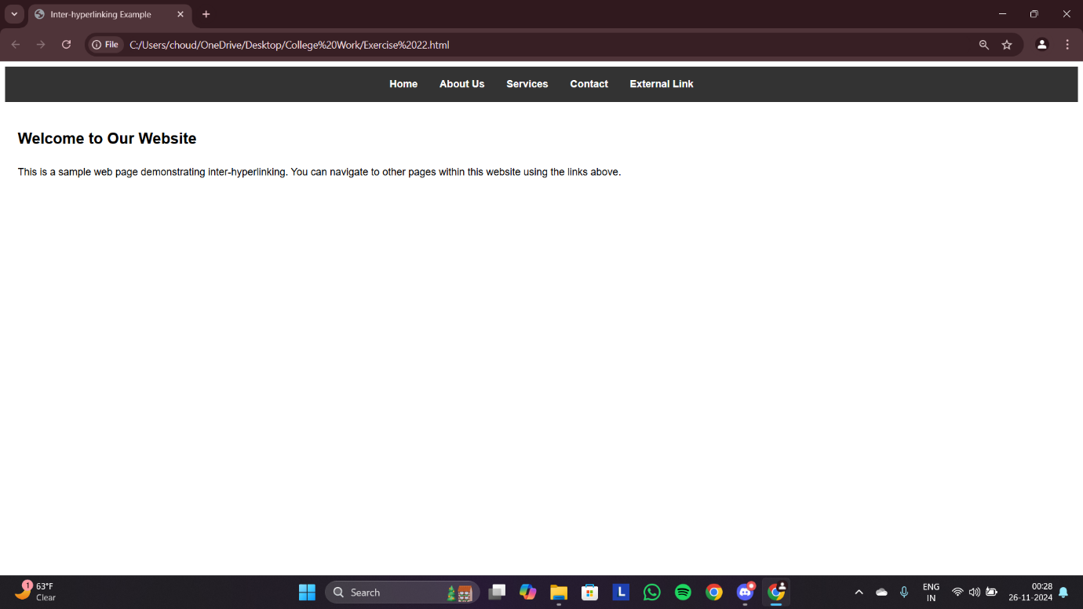

Q23: - Write HTML code for including External hyperlinking in a web page.

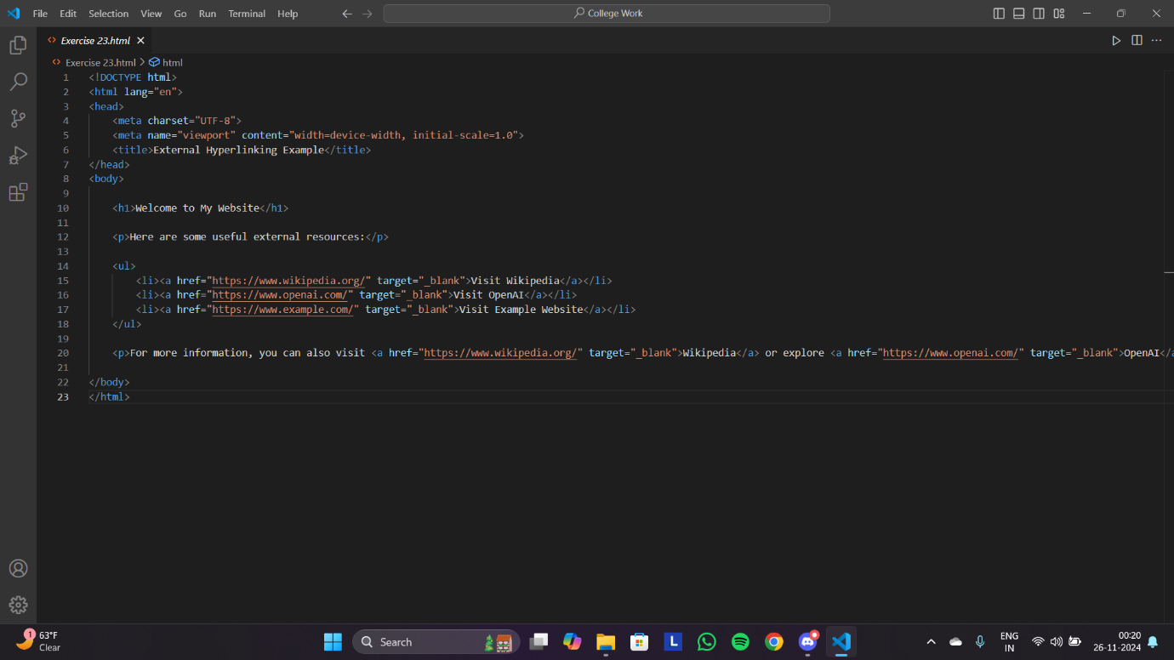

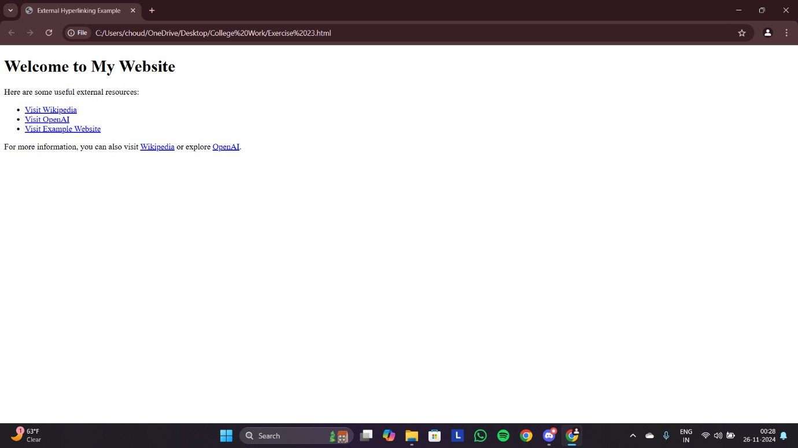

Q24: - Write code to show External CSS with HTML code.

HTML FILE: -

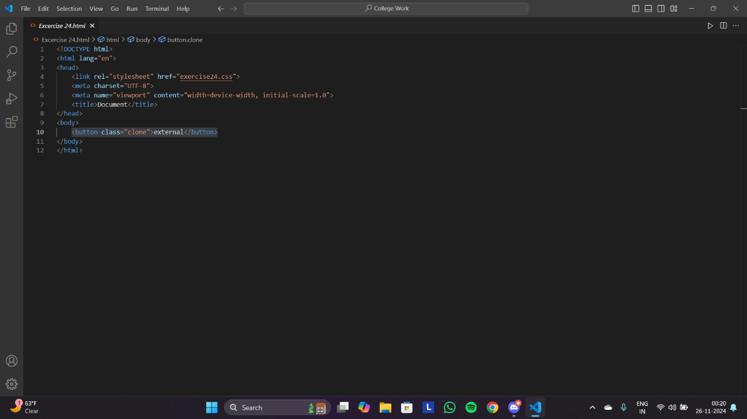

CSS FILE: -

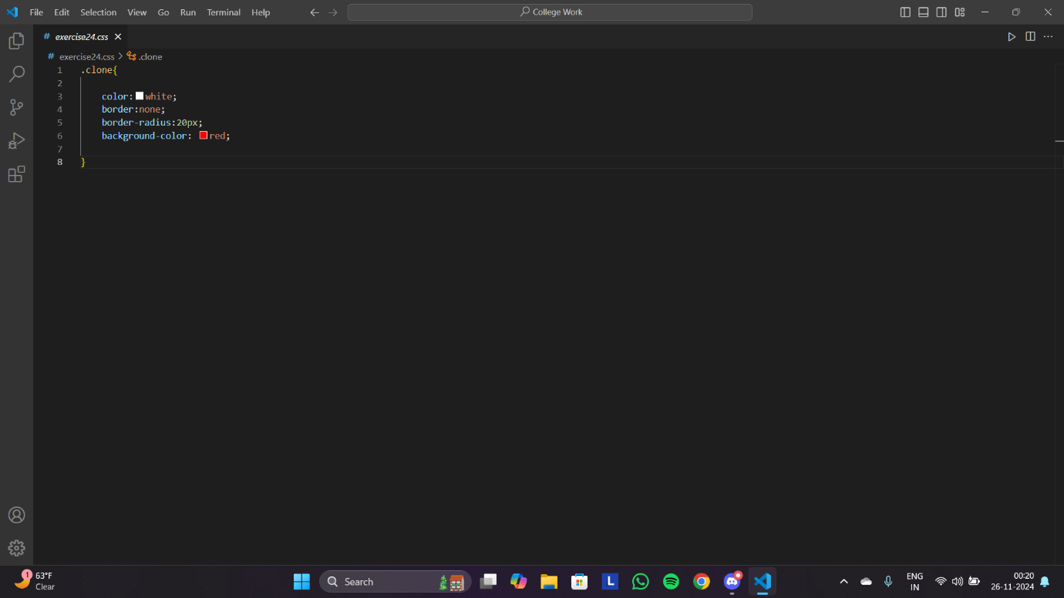

OUTPUT: -

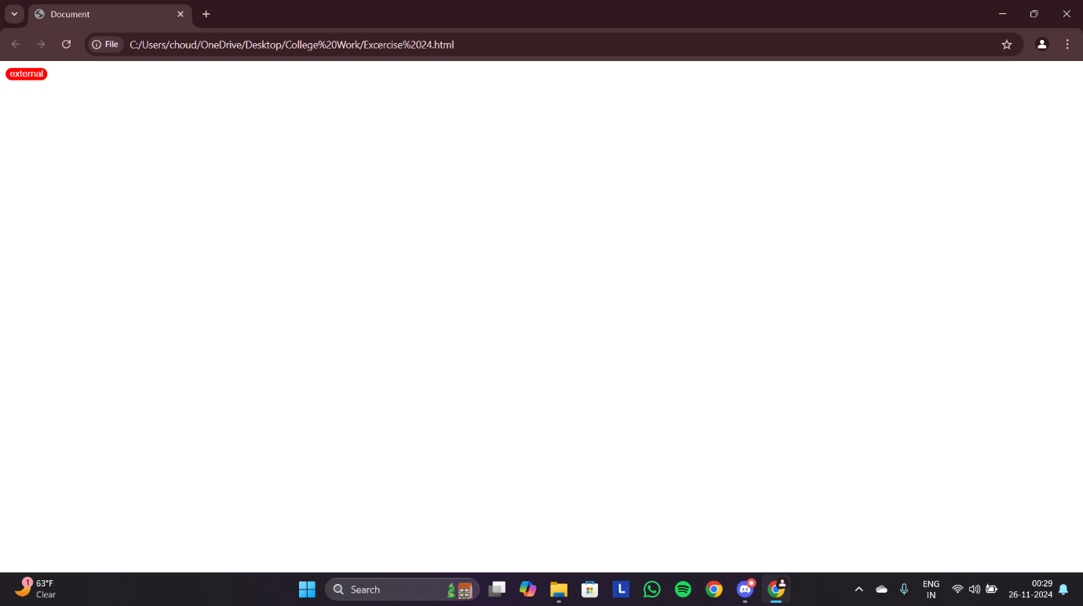

Q25: - Write code to show Internal CSS with HTML code.

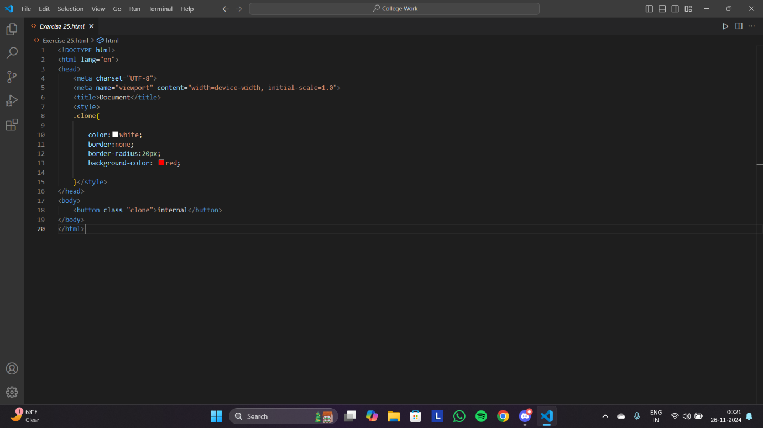

OUTPUT: -

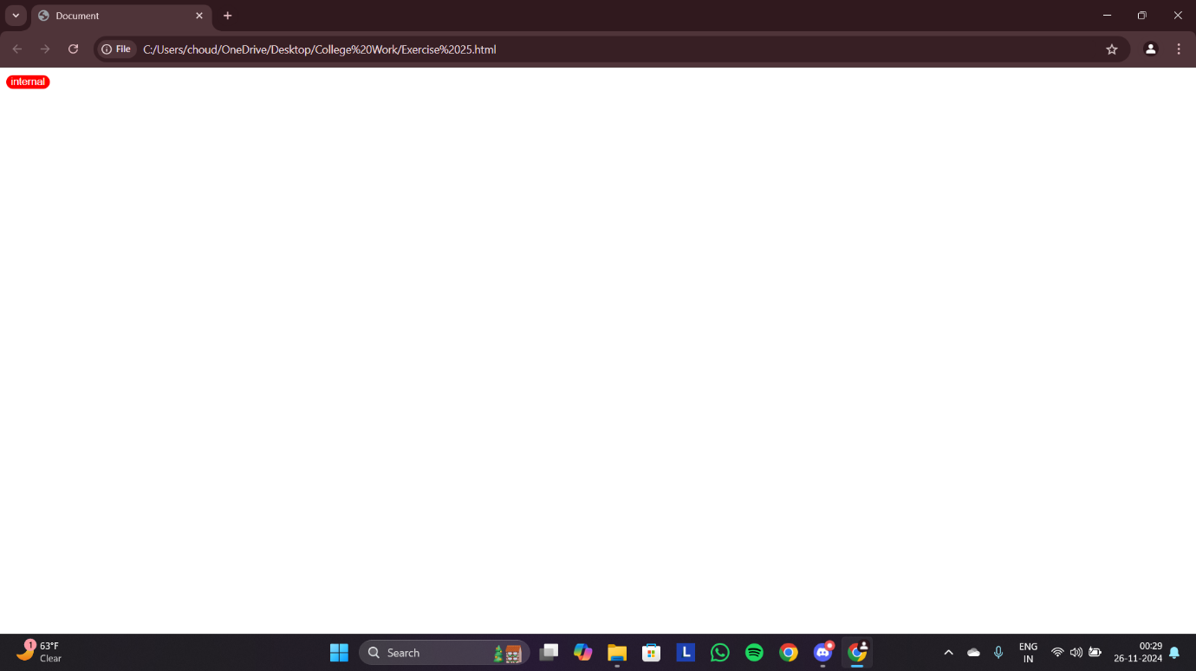

Q26: Write code to show Inline CSS with HTML code.

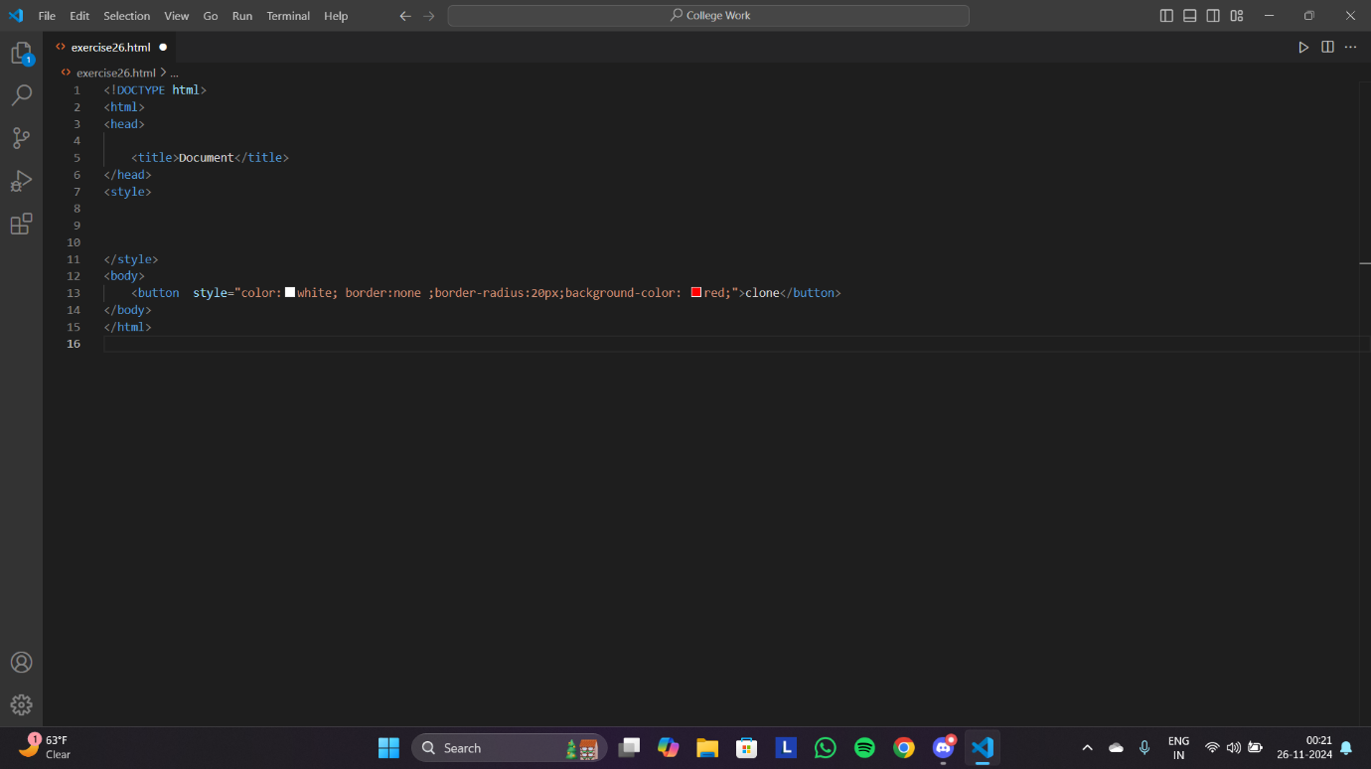

OUTPUT: -

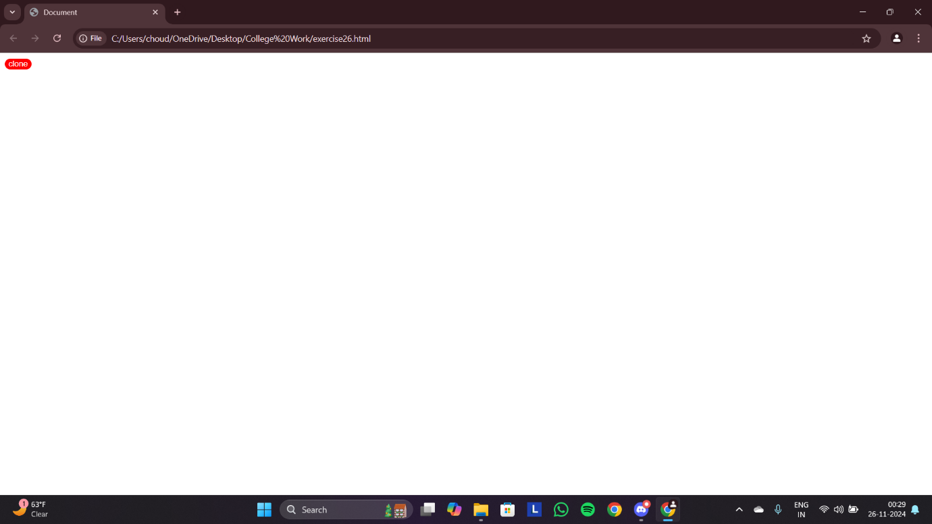

END.